Prentice J. Jacob Jr.
August 19, 1915 – November 22, 2007

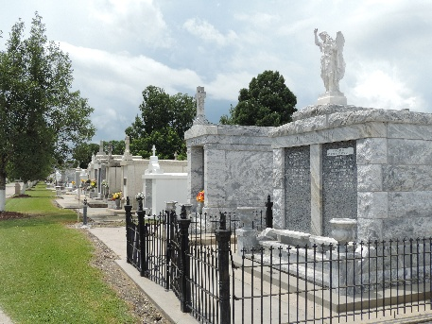

Prentice J. "Jake" Jacob, Jr. passed away on Thursday, Nov. 22, 2007. He was the beloved husband of the late Marie Therese Richaud Jacob, father of Darryl B. Jacob, son of the late Prentice J. Jacob Sr. and Maria Jacob, brother of Vera J. Clement, of Reserve, the late Venita J. Cambre, who was of Reserve, and the late Norman J. Jacob, and brother-in-law of Alden Clement Sr. Also survived by numerous nieces and nephews.
He was 92, a native and former 30-year resident of Reserve, a resident of New Orleans for 40 years and Belle Chasse since 1990.
Mr. Jacob was a veteran of World War II, a charter member of Veterans of Foreign Wars Post 5004 and a member of John P. April DAV Post 33. He retired from the Naval Air Station, New Orleans, as a civil employee with 29 years in December 1975. He was also a member of NARFE Chapter 41 and AARP. Mr. Jacob was active in the credit union movement and was president/CEO of NAS Credit Union, NAS New Orleans for more than 40 years. During his tenure, he was primarily instrumental for initiation and implementation of services as they were available and installation of computer enhancements to serve the Credit Union's field of membership. The Credit Union grew from a "Mom & Pop" operation to furnishing sophisticated operations of financial services for more than 4,000 members. In addition, Mr. Jacob was a member of the board of directors of the Louisiana Credit Union League for several years.
Relatives and friends of the family and members of NASJRB Credit Union are invited to attend a funeral service in the chapel of Mothe Funeral Home, 2100 Westbank Expressway, Harvey. Interment in St. Peter Catholic Cemetery, Reserve.
The Advocate, Baton Rouge, Louisiana
November 27, 2007

