Prentice Joseph Jacob Sr.
August 8, 1888 – October 25, 1961

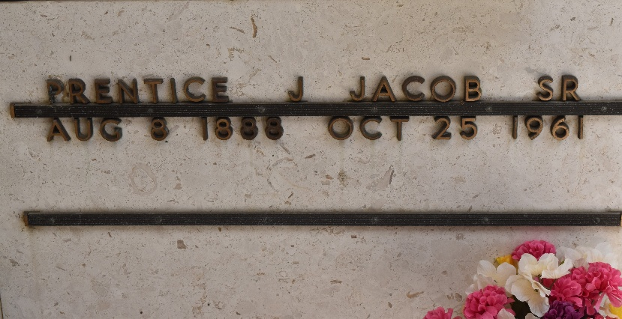
Photo by Team T-Lo

JACOB - at his residence, Reserve, La, on Wednesday, October 25, 1961, at 3:15 o'clock p.m., PRENTICE J JACOB SR, beloved husband of Maria Jacob; father of Prentice Jr., Norman Jacob and Venita Jacob and Mrs. Alden Clement; also survived by six grandchildren; aged 73 years; a native and resident of Reserve, La.

Relatives and friends of the family are invited to attend the funeral. Services from Millet funeral home, Reserve, La., on Friday, October 27, 1961, at 9:30 o'clock a.m. Religious services at St. Peter Church, Reserve, La. Interment in St Peter Cemetery, Reserve, La.
The Times-Picayune, New Orleans, Louisiana
October 26, 1961, p. 2

