Rickie George Jacob
October 19, 1952 – July 31, 2011

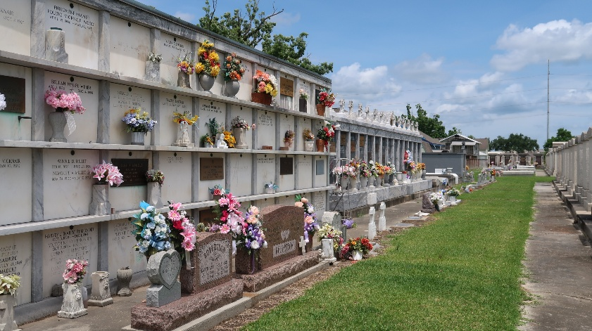

Rickie George Jacob passed away on Sunday, July 31, 2011. Beloved father of Tara Jacob Smith and Cory Jacob. Also survived by 3 granddaughters. Son of Lois Simon Jacob and the late Jean Jacob. Brother of Janel Jacob Masson, Bruce and Barry Jacob. Beloved Fiance of Donna Mayeaux. Also survived by Aunts, Uncles, Nieces, Nephews, Cousins, Great-Nieces and Nephews and numerous close loving friends. Age 58. A native and resident of Reserve.

Relatives and friends are invited to attend services. Visitation at Millet-Guidry Funeral Home, 2806 W. Airline Hwy., LaPlace, LA, on Friday, Aug. 5, 2011 from 8:00 am to 10:00 am, followed by Religious Services in the Funeral Home Chapel at 10:00 am. Burial in St. Peter Cemetery, Reserve, La.
The Times-Picayune, New Orleans, Louisiana
August 4, 2011

