Robert Jules Jacob Sr.
November 26, 1919 – February 25, 2005

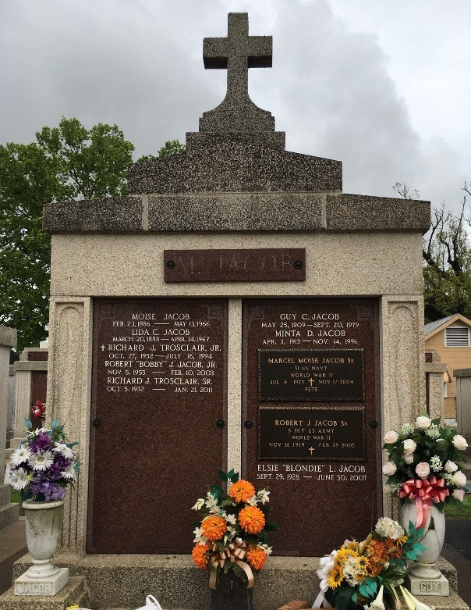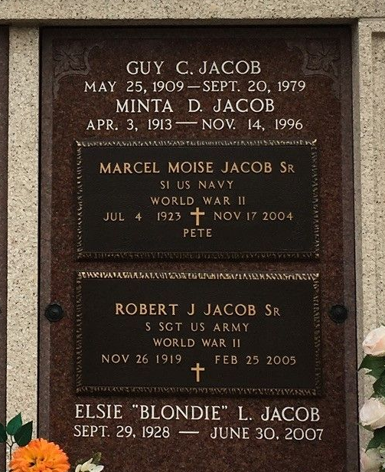
Photo by Team T-Lo

Robert Jules Jacob, Sr. On Friday, February 25, 2005 At 4:12 Am.
Beloved Husband Of Hazel Bergeron Jacob. Father Of Melanie J. Poche, Byron J. Jacob, Deborah J. Loupe, And The Late Robert J. Jacob, Jr. Father In Law Of Jackie Poche, Tammy Jacob, And Danny Loupe. Survived By 7 Grand-
children And 2 Great Grandchildren. Brother Of Shirleen Trosclair, Harry And Leonard Jacob, And The Late Alma Guillot, Guy, Allain, And Marcel Jacob.
Son Of The Late Moise And Lydia Cambre Jacob.
He Was A Veteran Of WWII And A Retired Sugar Clerk For Godchaux Sugary Refinery. Age 85 Years A Native And Lifelong Resident Of Reserve, La.
Relatives And Friends Of The Family Are Invited To Attend Services. Visitation At St. Peter Catholic Church, Reserve, La On Monday, February 28, 2005 From 8:30 Am Until 10:30 Am Followed By A Mass Of Christian Burial At 10:30 Am. Burial Will Be Private. In Lieu Of Flowers Masses Preferred. Millet Guidry Funeral Home, Laplace, La Is In Charge Of Arrangements.
The Times-Picayune, New Orleans, Louisiana
February 26, 2005

