Samuel Joseph Jacob Jr.
March 28, 1943 – February 12, 2019

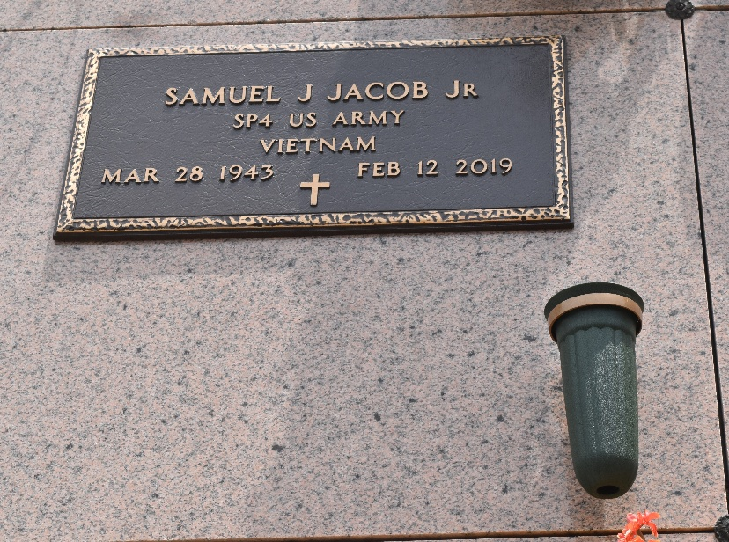

Samuel "Sam" J. Jacob, Jr. passed away at home surrounded by his family on Tuesday, February 12, 2019 at the age of 75. Sam was a 1962 graduate of Leon Godchaux High School and proudly served his country in the U. S. Army.

Beloved companion of 18 years to Carolyn Mattison. Loving father of Scott Jacob (Ratchel) and Mark Jacob (Kim). Grandfather of Brittney Jacob, Shane Jacob, Mark Jacob Jr., and the late Madison Jacob. Son of the late Samuel J. Jacob Sr. and Eleanor Jacob. Brother of Beverly Ingraffia, Rita Cancienne, Anatole "Touie" Jacob (Beverly) and the late Karen Jacob Bailey and Kirt A. Jacob (Sandra). Also survived by many nieces and nephews.

Relatives and friends are invited to attend the Funeral Mass at St. Peter Catholic Church, 1550 Hwy 44, Reserve on Saturday, February 16, 2019 at 11:00 a.m. The visitation will be held in church from 9:00 a.m. until 11:00 a.m. Interment in St. Peter Cemetery. Millet-Guidry Funeral Home in charge of arrangements.
The New Orleans Advocate, Louisiana
Feb. 14 to Feb. 16, 2019

