Herbert Allen James
July 1, 1927 – April 22, 2003

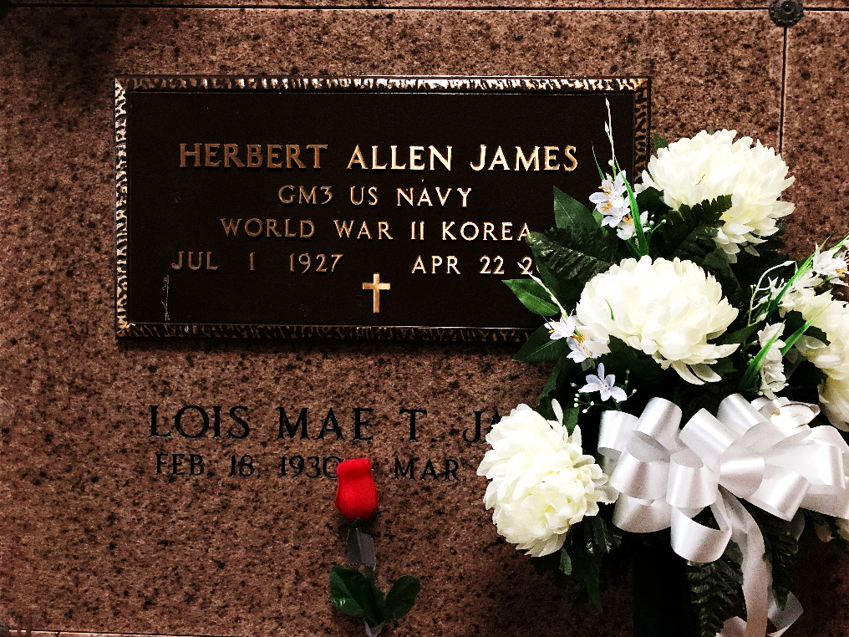
Photo by Team T-Lo

Herbert Allen James, a fitter and ironworker in ship and bridge construction, died Tuesday at his home. He was 75.
Mr. James was born in Spotsylvania, Va., and lived in Chalmette for the past 49 years. He was a member of Veterans of Foreign Wars Post No. 3337 in LaPlace. He was a Navy veteran of World War II and the Korean War.
Survivors include his wife, Lois Mae Torres James; three sons, Allen, John Michael and Warren James; a brother, Paul James; a sister, Pearl Sacra; eight grandchildren; and three great-grandchildren.
A Mass will be said today at 10 a.m. at Sacred Heart Catholic Church in Norco. Visitation will be from 8 to 9:30 a.m. at Alexander Funeral Home in Lutcher. Burial will be in St. Peter’s Mausoleum.

Unknown newspaper clipping

