John Michael James
January 21, 1956 – January 13, 2019

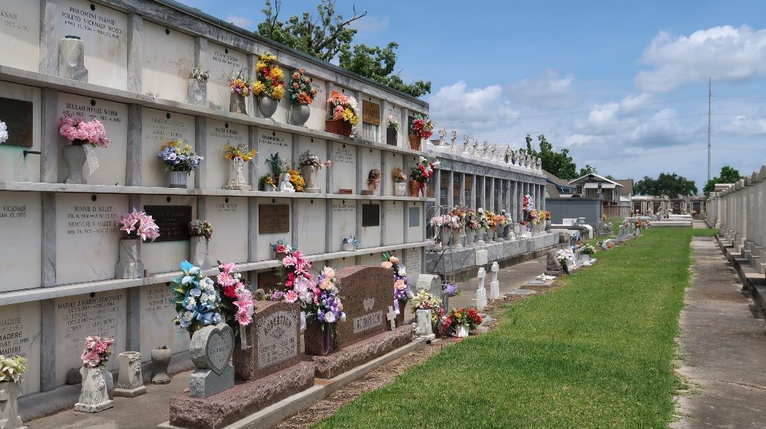

John Michael James was born on January 21, 1956 and passed away on January 13, 2019. He was the son of Herbert James and Lois Mae Torres and was known to all by his middle name of Michael. Survived by brother of Allen Joseph James.

Memorial Visitation will be held on January 24, 2019 at 6:00 pm at H.C. Alexander Funeral Home, 821 Fourth St, Norco, Louisiana. Interment will be held on February 5, 2019 at 10:00 am at St. Peter Cemetery.

Michael served in the US Navy. His cremated remains are buried in the same tomb as that of his mother, Lois Mae Torres James in St. Peter Catholic Church Cemetery, Reserve, St. John the Baptist Parish, Louisiana.

Unknown source

