Lois Mary Marie (Torres) James
February 18, 1930 – March 17, 2019

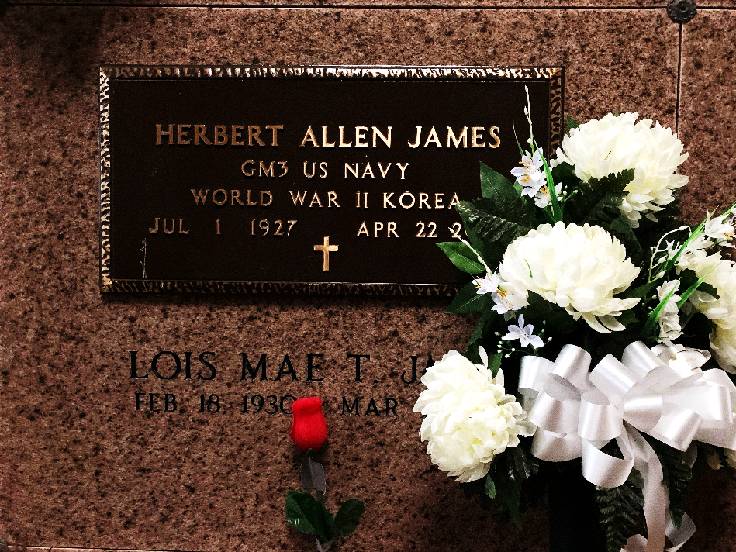
Photo by Team T-Lo

LoisMae Marie Torres James, born on February 18, 1930, passed away March 17, 2019 at the age of 89. She is survived by her son, Warren James, Sr. (MaryJo), grandchildren, Jason, Sara, Michael, Warren, Jr., Steven (Amy), Bryan, Brittany, and Juliana, 6 great-grandchildren, and her siblings, Lawrence Torres and MaryAnn Marse. She is also survived by her special caregiver and God-daughter, GayNell Becnel and many nieces, nephews, and family members to cherish her memory.
She is preceded in death by her loving husband, Herbert Allen James, sons, Allen and John James, daughter, Lois James, and her siblings, Warren Torres, Sr., Shirley Torres, C.J. Torres, Leonard Torres, Elaine Bergeron, Gloria Loupe, and Steward Torres.
LoisMae loved to sing in the choir, sew and especially loved to crochet. She will be greatly missed by all who were blessed to know her.
Relatives and friends are invited to attend a visitation at Sacred Heart of Jesus Catholic Church, 401 Spruce St. Norco, LA, on Saturday, March 23, 2019 beginning at 9 AM, a Mass of Christian Burial will be held at 11 AM. Burial to follow at St. Peter Cemetery, 1550 LA-44, Reserve, LA. Flowers welcomed, Masses preferred.

H.C. Alexander Funeral Home, Norco, Louisiana

