Ruth (Jacob) James
November 1, 1917 – March 17, 2012

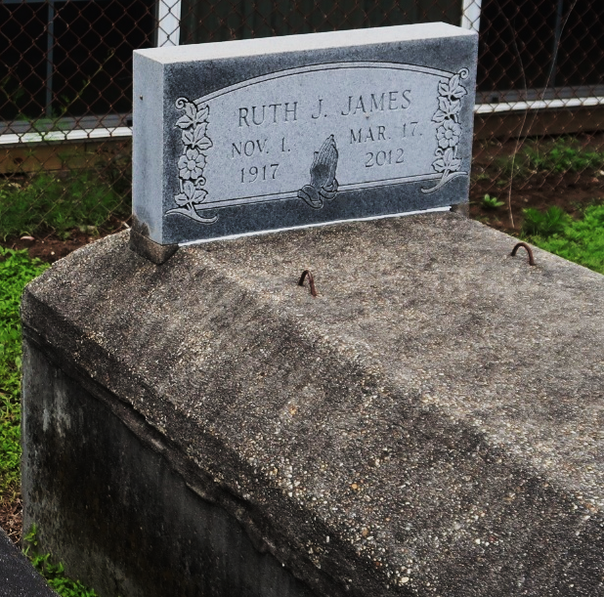

Ruth James on Saturday, March 17, 2012 at River Region Hospice, River Ridge, LA.
Daughter of the late Cornelia Charles and Sam Jacob. Wife of the late Joseph James, Sr. Mother of Rosalie J. Lewis (Alvin), Mary Hampton, Joseph Gerald James, Jr. (Olga), Gloria Dumas (Sylvester), Leonard, Milton, Melinda and Wayne James and the late Fredrick James. Mother-in-law of Cheryl James. Also survived by 31 grandchildren, 55 great-grandchildren, 4 great-great-grandchildren, 2 expectant great-great-grandchildren and a host of nieces, nephews, other relatives and friends. Age 94 years. A native of St. James, LA and resident of Reserve, LA.
Relatives and friends of the family, also priests and parishioners of Our Lady of Grace Catholic Church and all neighboring churches are invited to attend the Funeral Mass at Our Lady of Grace Catholic Church, 772 Highway 44, Reserve, LA on Saturday, March 24, 2012 at 10:00 AM. Fr. Roderick Coats, Celebrant. Interment St. Peter Cemetery, Reserve, LA. Visitation at the above named church from 8:30 AM until Mass time. SERVICED BY ROBOTTOM

The Times-Picayune, New Orleans, Louisiana
March 22-23, 2012

