Cecilia (Montet) Jay
March 8, 1857 – January 21, 1945

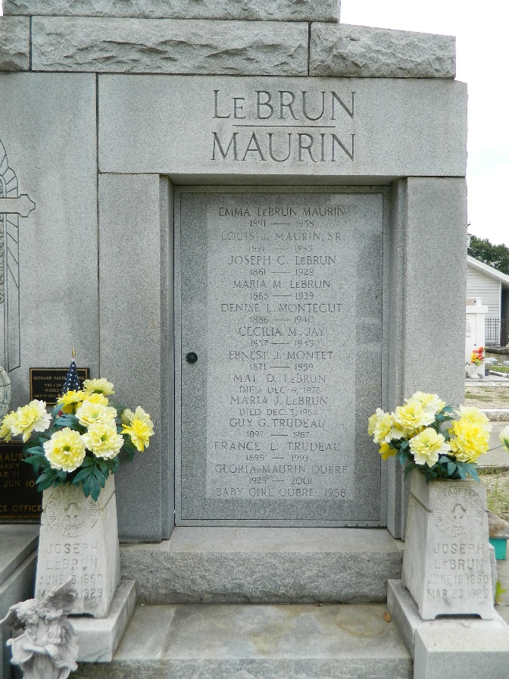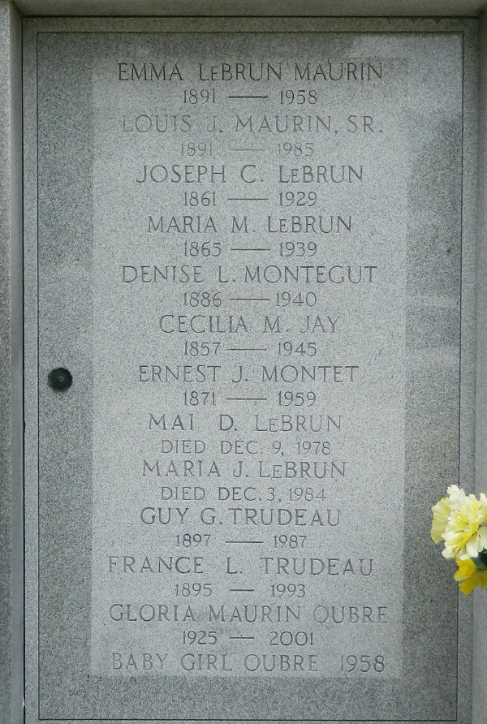

JAY-At Reserve, La, on Sunday, January 21, 1945, at 8 o'clock a.m., CECILIA MONTET JAY, sister of Ernest Montet and the late Mrs. J. C. LeBrun and Edmond Montet; aunt of Mrs. Louis J. Maurin, Mrs. Guy G. Trudeau, Maria and Mai LeBrun and the late Mrs. J. J. Montegut; aged 87 years, 10 months, 18 days; a native of Laroche Chalais, France, and a resident of St John parish for 35 years.
Relatives and friends of the family are invited to attend the funeral, which will take place from the LeBrun residence, Reserve, La., on Monday, January 22, 1945, at 9:30 o'clock a.m. Religious services at St Peter's church, Reserve, La. Interment in St Peter's cemetery, Reserve, La. Millet's funeral home in charge.
The Time-Picayune, New Orleans, Louisiana
January 22, 1945

