Marie (Charles) Johnson
October 11, 1942 – May 26, 2013
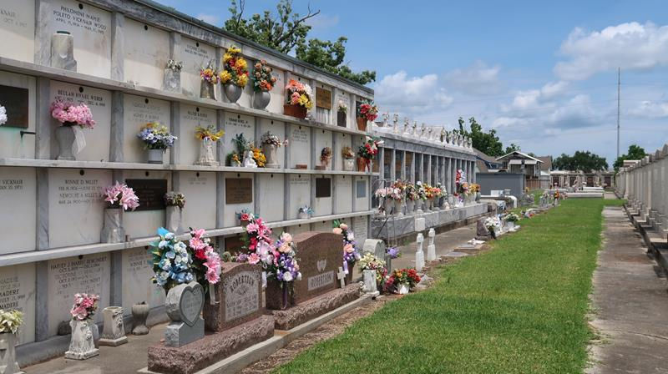
Marie C. Johnson departed this life on Sunday, May 26, 2013. She is survived by her spouse; Leo Johnson, her children Joi Farlough-Matthews Alpharetta, GA, Carnelle Farlough-Brown, Los Angeles CA, Blayne Farlough, Laplace, LA, Renaldo Johnson, Buford, GA and Melentia Johnson Adams, Norco, LA, 5 loving grandchildren, 2 sisters; Linda Charles Clayton and Donna Charles Jackson of Laplace, LA., 2 brothers; Bernell Charles, Reserve, LA and Walter Charles of Los Angeles, CA and a host of nieces and nephews.
Funeral services and Mass of Christian Burial for Marie Charles Farlough Johnson, will be held at 10:00 a.m. on Wednesday, June 5, 2013 at Our Lady of Grace Catholic Church, 772 River Road, Hwy 44, Reserve, La. Burial will be at St Peters Cemetery, Reserve, LA. The family will greet friends from 9:00 - 10:00 a.m. The rosary will be recited prior to the mass.
Her son Harold Joseph Farlough, Jr. her brother, Warren Eugene, and her sister Janice Charles Jackson preceded her in death.
Services Entrusted to Hobson Brown Funeral Home 134 Daisy St. Garyville, La 70051 985-535-2516

The Times-Picayune, New Orleans, Louisiana
May 31 to Jun. 2, 2013

