Rustin D. Johnson
December 2, 1951 – March 7, 2010

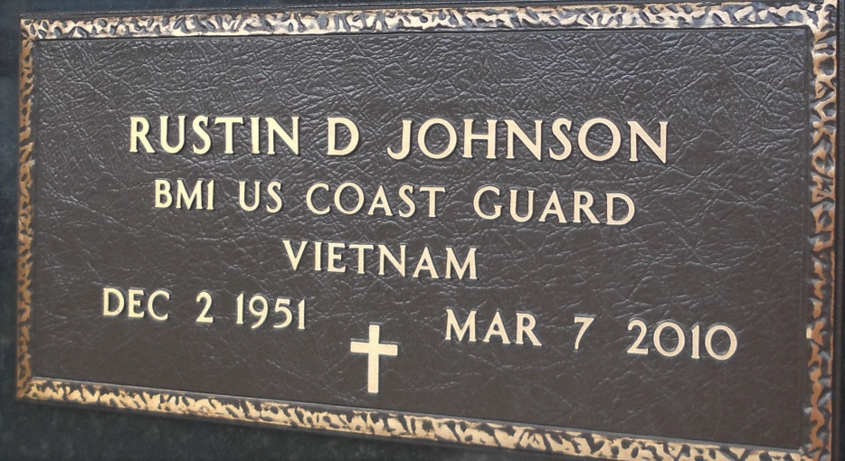
Photo by Team T-Lo

We are saddened that God has taken our beloved Rustin D. Johnson, at age 58. After 8 courageous years of battling heart disease, he passed away on Sunday, March 7th, 2010.
He is survived by his loving partner, Natalie Benenate. He was the loving father of Jennifer West (Jeremy), Jeremiah Johnson (Lindsay), and James Johnson. Beloved "Paw-Paw" of Rustin West. Brother of Sherry Langgle, Sandy McFarland, Scott Johnson, Amy Johnson, and the late Andrew Johnson. Former son-in-law of Elizabeth "Clancy" Duhe Ramagos.
Rusty served in the United States Coast Guard for 10 years. After serving his country, he founded Industrial Cleanup Inc. (ICI), and successfully ran it for 25 years. He sold his company, in March 2009, to enjoy retirement and his family.
Relatives and friends of the family are invited to attend the funeral services at St. Peter's Catholic Church in Reserve, LA on Thursday, March 11, 2010. Visitation will begin at 9:00 a.m. with a funeral mass at 12:00 p.m. Interment will follow at St. Peter's Cemetery.
The Times-Picayune, New Orleans, Louisiana
Mar. 9 to Mar. 10, 2010

