Tramund Michal Joseph
January 26, 1969 – February 3, 2021

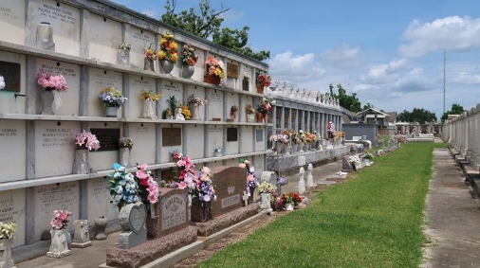

Tramund Michal Joseph "Cha-Cha" 53, of Mount Airy, LA, unexpectedly passed away and entered into eternal rest on February 3, 2021. He was born to parents Ernestine Washington and Stanley Joseph, Sr., on January 26, 1969, in New Orleans, LA. He was a proud graduate of East St. John High, class of 1986. Tramund's hobbies included all things football, he loved football and his favorite player was quarterback, Tom Brady.
Cha-Cha lit up the room with his jokes, quick wit, dynamic personality and sarcastic remarks. He was a friend to all who knew him, even if he met them for the first time. He was indeed well known and loved.
Tramund was employed as a manager at Burger King Enterprises for 15 years, however, the last two years he worked in shipping and receiving at Minnesota Warehouse in Minneapolis, MN. While residing there, he became friends with many, and even considered some family.
Tramund leaves to cherish his memories; his only son, Tyangelio Gaines (Brittany); grandchildren, Amare and Zavier Gaines; his mother, Ernestine "T.T." Washington; Devoted friend, Gregory Mizell; Stepmother, Laura Joseph; Godparents, Anita and Larry Jones; Aunts, Rosemary, Denise and Claudia Washington, Glendora Grant, and Helen Wilson; Uncles, Fredrick, Wilbert, and Ernest Washington; his brothers, Stanford, (Chevrette), Stanley, and Michael Joseph (Jalisa) and Derrick Robertson (Tanza), Reggie Miller and James Wood. Sisters; Angela Washington, Tiki Malon Collins (Rory) and Ethel Joseph. Nieces; Tierenie Hurst (Frank), Danielle Joseph, Ashley Collins. Nephews: Thaddeus Scott Jr, Stanford Perry "Poo," and Bruce Joseph; and a host of cousins, other relatives, and friends.
He was preceded in death by his father - Stanley Joseph Sr., brother - Devin Joseph, stepson - Tevin Phillip. Maternal grandparents; Ernest and Rosemary Washington, his Paternal grandparents; Celestine Sr. and Ethel Joseph. Aunts; Elaine and Emelda Washington, Sybil Joseph and Adeline Alexis. Uncles- Larry, Lionel, and Celestine Joseph.
A private service will be held Friday, February 12, 2021 at 11 a.m. at Bardell's Mortuary, 3856 LA- 44, Mt. Airy, LA 70076. Interment: St. Peter Catholic Cemetery. Viewing will be held Thursday, February 11, 2021 from 5 p.m. until 7 p.m. at Bardell's Mortuary.

The Times-Picayune, New Orleans, Louisiana
February 10-12, 2021

