Alexis Charles Jouty
March 2, 1924 – July 3, 2013

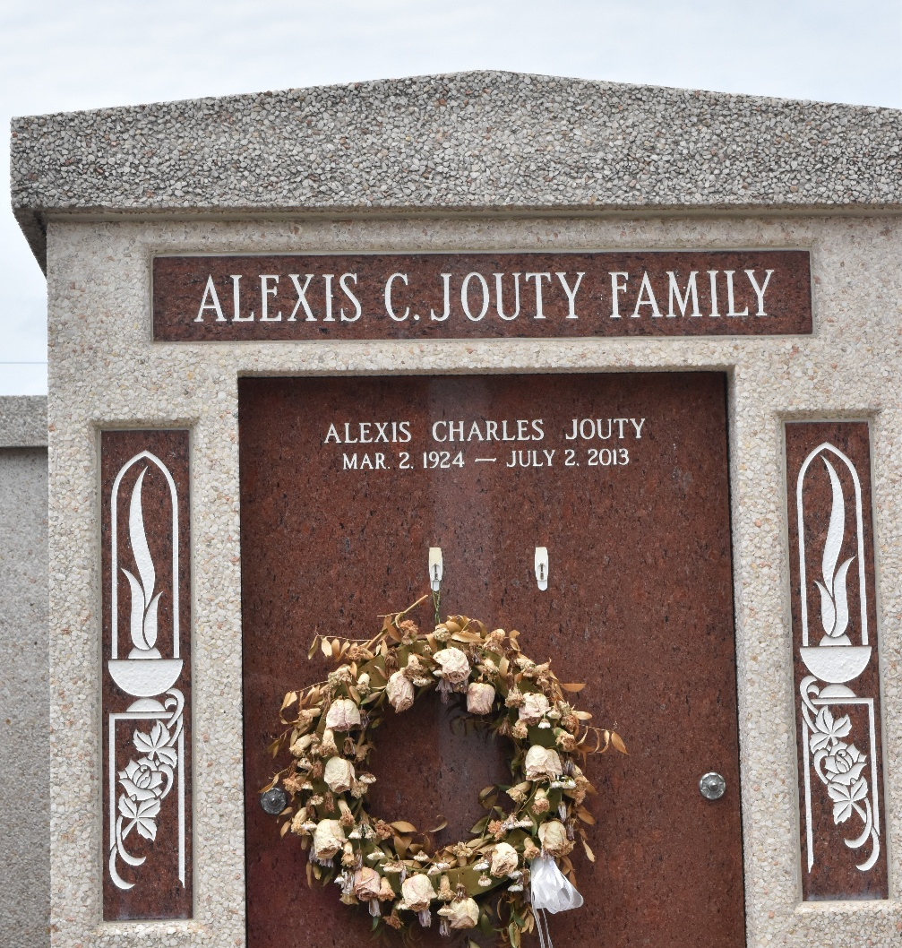

Alexis C. Jouty died on Tuesday July 2, 2013. Beloved husband of Earline Weber Jouty. Father of Charles and Chris Jouty, Patricia Karr, Teresa Millet and Pamela Bondi. Also 9 grandchildren and 9 great-grandchildren. Son of the late Hyacinthe and Lucie Jouty. Brother of the late Leon, Frank, Eddie and Victor Jouty, and Leonie J. Conrad. Age 89. A native and resident of LaPlace, LA.
Relatives and friends are invited to attend services. Visitation at Millet-Guidry Funeral Home, 2806 W. Airline Hwy., LaPlace, LA on Friday July 5, 2013 from 8:00am to 9:30am, followed by Mass at St. Peter Catholic Church, Reserve, LA at 10:00am. Burial in St. Peter Cemetery, Reserve, La.

The Times-Picayune, New Orleans, Louisiana
July 2-3, 2013

