Earline (Weber) Jouty
July 2, 1928 – April 16, 2023

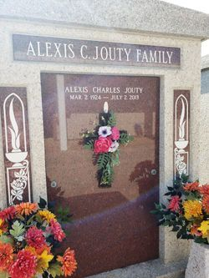
Photo by Team T-Lo

Earline Weber Jouty was born on July 2, 1928 in Reserve, LA to the late Bernard and Lucette Weber of Norco, LA and passed away on April 16, 2023 at Landmark Nursing Home in Hammond, LA. She was married to the love of her life Alexis Jouty and resided in Laplace, LA. Earline is survived by her children Patricia (Gary Karr), Charles Jouty (Carolyn), Chris Jouty (Terry), Teresa Millet, and Pamela (Philip Bondi). Grandchildren Windy, Michael, Christopher, Shannon, Lori, Lisa, Kristin, Evan and Alexis as well as 9 great grandchildren and numerous nieces and nephews. In addition, she leaves behind her siblings Elsie Louque, Kathleen Ory, Elaine Marcantel, Irene Arceneaux and Charles Weber.
She is preceded in death by her devoted husband of 74 years Alexis Jouty as well as her siblings Marion Guidry, Mildred Montz, & Bernard Weber. Earline loved spending time with her family, gardening, & admiring her flowers on a beautiful sunny day.
Her family wants to thank Landmark Nursing Home, Life Source Hospice, and a very special “Thank You” to Jasmine Dillon for her love and devotion to our mom.
Relatives and friends are invited attend the visitation and mass on Monday, April 24, 2023 at St. Joan of Arc Catholic Church, 529 W. 5th Street, LaPlace. Visitation will begin at 9:30 a.m. followed by mass at 11:00 a.m. Interment to follow at St. Peter Cemetery in Reserve, LA.

Millet Guidry Funeral Home, LaPlace, Louisiana

