Gertrude (Brou) Keating
September 19, 1903 – May 4, 1984

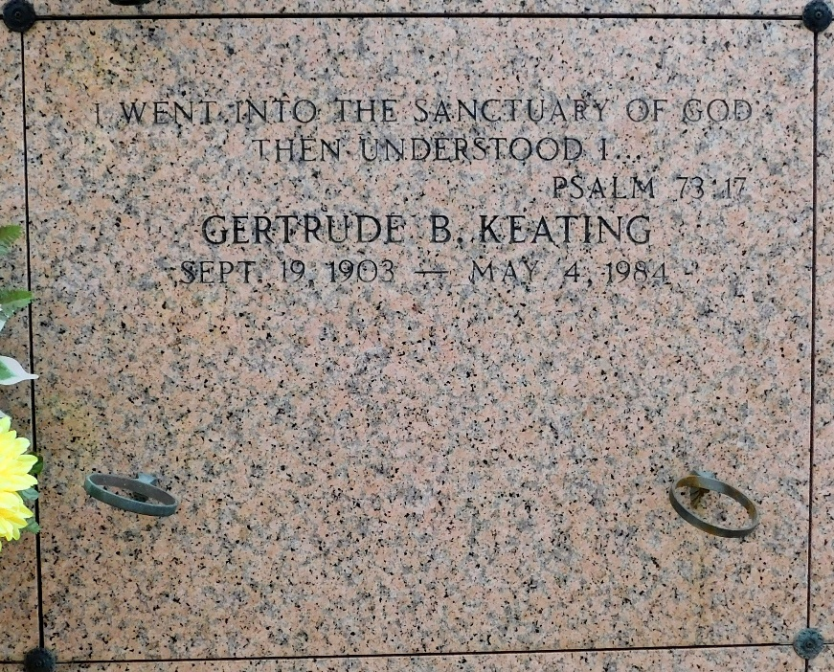
Photo by Mary Agnes Hammett

Gertrude Brou Keating, on Friday, May 4, 1984, at 7:05 p.m., wife of the late Seraphin Keating, Jr., mother of Curtis and Jerry Keating, of LaPlace, sister of Elvina Vicknair and Stanley Brou; survived by 6 grandchildren and 3 great-grandchildren; age 80 years; a native of Lucy, La. and a resident of LaPlace for the past 54 years.
Relatives and friends of the family are invited to attend the funeral services from the Millet Funeral Home, LaPlace, La., on Monday, May 7, at 11:30 a.m. followed by religious services at St. Joan of Arc Catholic Church, interment in St. Peters Cemetery, Reserve, La. Friends may call from 5 p.m. to 10 p.m. on Sunday, May 6, and from 8 a.m. until services on Monday, May 7.

The Times-Picayune, New Orleans, Louisiana
Sunday, May 6, 1984, Sec. 1, p. 36

