Glen Anthony Keating
June 7, 1959 - May 1, 2019

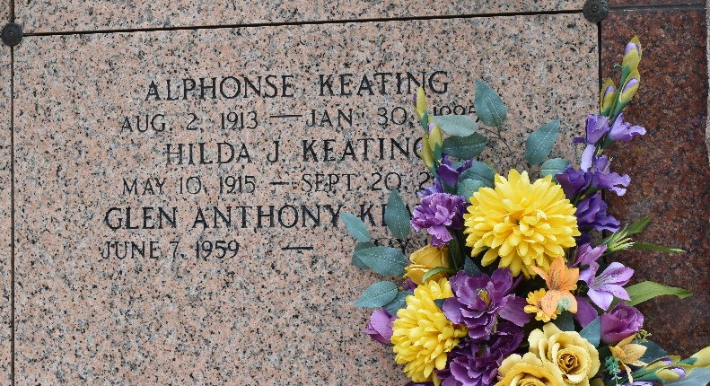

Glen Anthony Keating, loving husband, father and grandfather, passed away at his residence on Wednesday, May 1, 2019 at the age of 59. He was born in New Orleans and was a resident of LaPlace. Glen retired from Shell Oil Company in Norco. He was a parishioner and usher for St. Joan of Arc Catholic Church. Glen was a member and former King XLI of the Krewe of Allovus. He enjoyed cooking for others and was a lifelong fan of Disney and LSU sports.
Beloved husband of 39 years to Darleen Jacob Keating. Loving father of Aaron Paul Keating (Sarah), Jennifer Keating Evans (Joshua) and Megan Ann Keating. Grandfather of Anderson Keating, Harrison Keating, Byron Evans, Jacob Evans and Addelyn Redmond. Son of Ferrol Anthony and Frances Madere Keating. Brother of Robert Keating (Maria) and Lynne Keating Miller (Timmy). Son-in-law of Oscar Jerry Jacob and the late Nelwyn Cambre Jacob. Brother-in-law of Denise Jacob Morrow (Brian) and Jeri Lyn Preston (Scott). Also survived by many nieces, nephews, extended family and lifelong friends.
Relatives and friends are invited to attend the Funeral Mass at St. Joan of Arc Catholic Church, 529 W 5th Street, LaPlace, LA on Saturday, May 4, 2019 at 12:00 p.m. Visitation will be held in church from 10:00 a.m. until 12:00 p.m. Interment in St. Peter Cemetery. In lieu of flowers, please consider mass intentions at St. Joan of Arc.

Millet-Guidry Funeral Home, LaPlace, Lousiana
May 3, 2019

