Hilda Marie (Jacob) Keating
May 10, 1915 – September 20, 2007

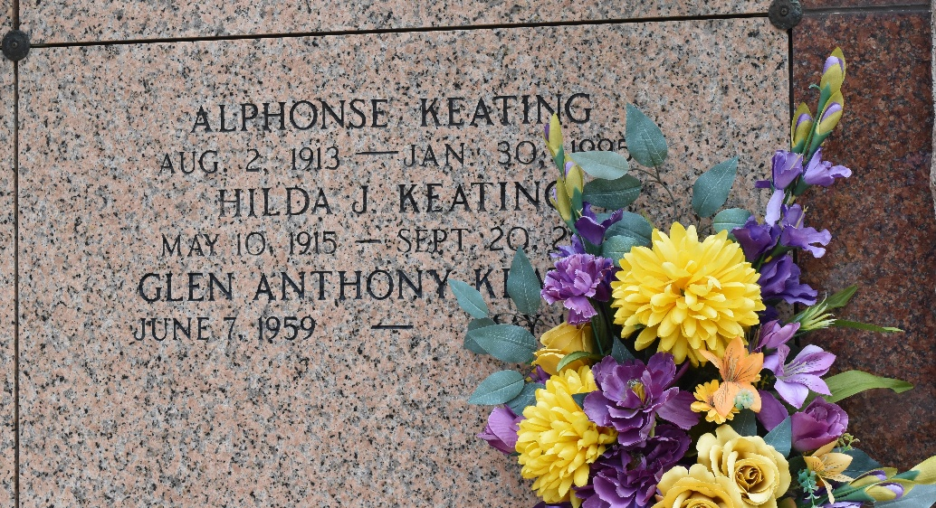

Hilda Jacob Keating, on Thursday, September 20, 2007 at 6:35 p.m. Beloved wife of the late Alphonse Keating. Mother and mother-in-law of Ferrol (Coco) and Frances Keating. Grandmother of Glen and Robert Keating and Lynne Miller. Great-grandmother of Aaron, Jennifer and Megan Keating, Amanda, Tiffani and Taylor Miller. Daughter of the late Jerome and Noelie Jacob. Sister of the late Nolan and Herman Jacob. She was a very loving and caring person who loved to cook. The family would like to thank Twin Oaks Nursing Home and St. Joseph's Hospice for their loving care. Age 92. A native of Reserve and a resident of Laplace for the past 70 years.
Relatives and friends are invited to attend services. Visitation at Millet-Guidry Funeral Home, 2806 W. Airline Hwy., Laplace on Monday, September 24, 2007 from 9 am to 11 am, followed by Religious Services at the funeral home chapel at 11 am. Burial in St. Peter Cemetery, Reserve.
The Times-Picayune, New Orleans, Louisiana
Sep. 23, 2007

