James "Jacques" Keating
August 9, 1959 - February 24, 2024

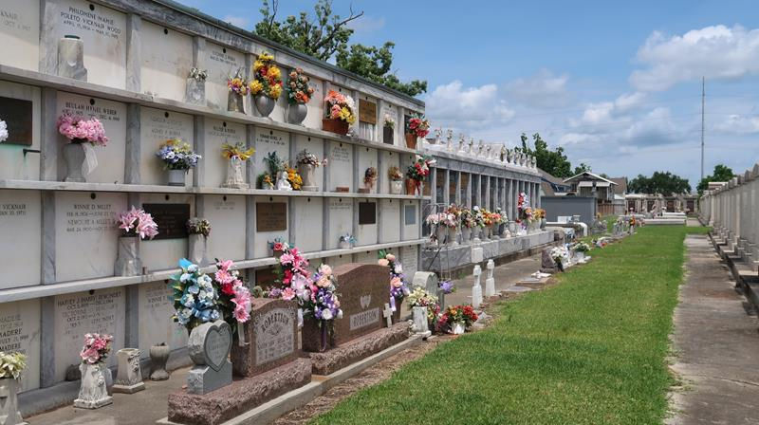

James “Jacques” Keating passed away on Saturday. February 24, 2024 at the age of 64.
Beloved husband of Anna Keating for 41 years. Loving father Jami Caldarera (Ryan) and Ali Huguet (Jon). Grandfather of Dax Caldarera, Gavin Caldarera, Hayden Caldarera, and Ellis Huguet. Son of the late Ray Keating and Lucy St. Germain Keating. Brother of Jane LeBoeuf (Robert), Holly Johnson (Lawrence), Willie Keating (Judy), Mark Keating (Maria), the late Carol Trahan, and Ray Keating, Jr. Uncle of the late Alex LeBoeuf. Also survived by numerous nieces, nephews, and cousins.
Jacques was an avid hunter and fisherman, spending a lot of time at his camp in Lake Maurepas. He loved spending time with his family, especially his grandchildren. He was a big LSU Tigers and Chicago Cubs fan. If he wasn’t hunting, fishing, or with his grandchildren he was probably at Don’s Country Store or woodworking in his garage.
Relatives and friends are invited to attend the Visitation and Memorial Mass on Thursday, February 29, 2024 at St. Peter Catholic Church. Visitation will be held 9:00 a.m. to 11:00 a.m. followed by a Memorial Mass at 11:00 a.m.
The family would also like to thank the donor family for the additional 10 years of life, their generosity provided.

Rose Lynn Funeral Home, Lutcher, Louisiana
February 25, 2024

