Alma (Cambre) Keating
April 24, 1938 – January 15, 2019

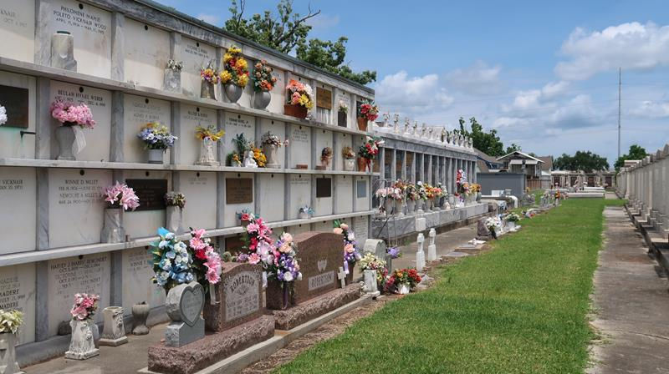

Alma C. Keller, born April 24, 1938, passed away Jan. 15, 2019, at the age of 80. Alma C. Keller She was the loving wife of the late Roland Keller Sr.; mother of Rachel K. Zeringue (Dirk Sr.), Ernest Cambre Sr.; Roland Keller Jr. (late Joanie) and Kirk Keller; grandmother of Ashley Zeringue (Max), Ernest Cambre Jr., Kimberly Keller, Dirk Zeringue Jr., Kristen Keller, Corey Keller (Samantha) and Brandon Keller (Carly); and great grandmother of Haleigh and Brycen Wetzel, Jayden and William Cambre, Eugene Doyle, Norielle, Nathan, Bria and Isla Keller. She is also survived by her siblings, Mary Simon (Junior), Michel (Boyo) Cambre (late Valrie), Terry Cambre (Lisa), Paul Cambre, Daniel Cambre (Sharon) and Stanley Cambre.
Alma was preceded in death by her parents, Bernard and Adrienne Oubre Cambre, and siblings Walter Cambre Sr., Bernard Cambre Jr., Mable Hidalgo, Alice Hebert, Betty Jean Cambre and Bernice Cambre.
Relatives and friends are invited to attend a Visitation beginning at 10:30 a.m. Thursday, Jan. 24 at St. Joan of Arc Church in LaPlace. A Mass of Christian Burial will be held at noon. Burial follows at St. Peter Cemetery in Reserve. To view and sign the online guest book, visit HCAlexander.com.

L'Observateur, LaPlace, Louisiana
January 21, 2019

