Aristide P. Keller
September 8, 1897 – January 14, 1919

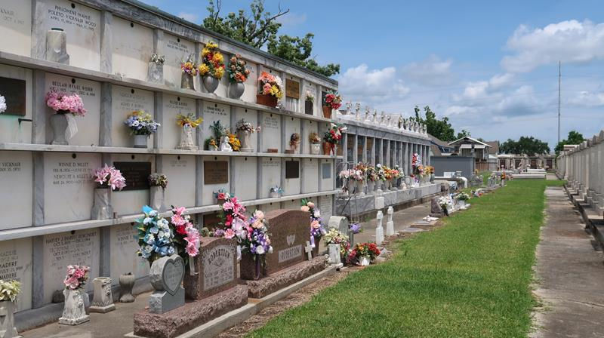

After a brief illness with pneumonia, growing from an attack of Influenza, Aristide P. Keller, son of Mrs. Widow Louis Keller of Reserve, passed away at 4:45 o'clock Tuesday afternoon, in the Charity Hospital, in New Orleans, aged 21 years, 4 months and 6 days.
Young Keller had left this his native parish a few years back to go to the city where he was conducting a moving picture show. A young man of magnetic personality, attractive appearance and the highest integrity, he made friends of all who he came in contact and a pall of gloom was cast over this community by the announcement of his untimely demise.
The funeral took place here at St. Peter's Church Thursday at 10 o'clock in the morning.
Besides his mother, he leave three brothers, Dantes, Freddy and Sidney, and two sisters, Mrs. Joseph Duhe and Miss Andreah Keller.

L'Observateur, LaPlace, Louisiana
January 18, 1919, p. 1

