Calvin Henry Keller
June 7, 1930 – February 19, 2027

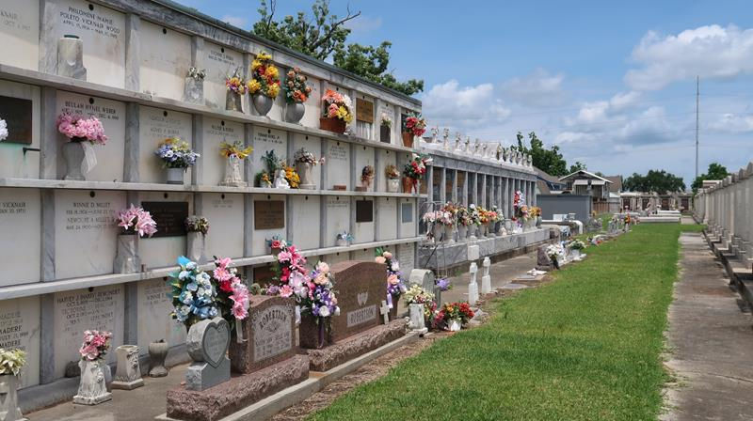

Calvin Henry Keller "Sudee" "Cal" on Sunday, February 19, 2017 at his home in Reserve, LA. Son of the late Elsie Green and Henry Keller. Husband of the late Lula Belle Borne Keller, Father of Roxanne Keller, the late Rodney Keller and Vincent Lott Brother of Joyce K. Lapeyrolie, Frank Keller and the late Allen Keller "Tac Toe" Also survived by 6 grandchildren, 13 great grandchildren and a host of nieces, nephews, cousins, other relatives and friends. Age 86 years. A native and resident of Reserve, LA.
Relatives and friends of the family, also priest and parishioners of Our Lady of Grace and Ascension of Our Lord Catholic Churches and all neighboring churches, members of Knights of Peter Clavier Council #73, Knights of Peter Clavier E O Moss Assembly #4 and St. John Parish Council on Aging are invited to attend the Funeral Mass at Our Lady of Grace Catholic Church, 772 Hwy 44 (River Road), Reserve, LA on Saturday, February 25, 2017 at 10:00 AM. Father Christopher Amadi, Celebrant Interment St. Peter Cemetery, Reserve, LA. Rosary at 9:15 AM Visitation at the above named church from 8:15 AM until Mass time. SERVICED BY ROBOTTOM

The Times-Picayune, New Orleans, Louisiana
Feb. 21 to Feb. 24, 2017
**

U.S., Department of Veterans Affairs BIRLS Death File, 1850-2020

Name Calvin Henry Keller
Gender Male
Birth Date 7 Jun 1930
Death Date 19 Feb 2017
Enlistment Branch Air Force
Enlistment Date 31 May 1951
Discharge Date 22 Oct 1953
Page number 2

