Dantes J. Keller
May 28, 1884 – April 28, 1968

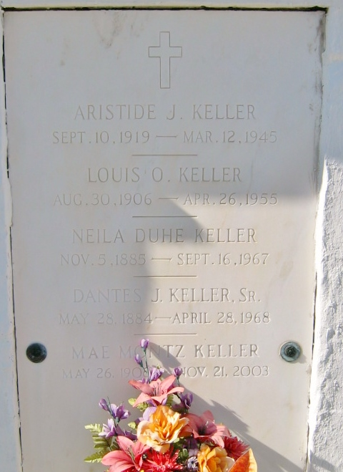
Photo by Bobby

KELLER - On Sunday, April 28, 1968, at 6:10 o'clock p.m., Dantes J Keller Sr, husband of the late Nelia Duhe; father of Joseph, Percy and Carol Keller and Mrs. Alvin Kewe, all of Reserve, La, Nolan and Dantes Keller Jr and Mrs. Roy Schexnayder of Baton Rouge, La, and the late Louis and Aristide Keller; brother of Mrs. Raoul Luminias Sr and Sidney J Keller Sr of Reserve, La. Also survived by 30 grandchildren and 11 great grandchildren. Age 84 years. A native and resident of Reserve, La.
Relatives and friends of the family, also employees of Godchaux Sugar Refinery, Reserve, La, are invited to attend the funeral. Services from Millet Funeral Home, Reserve, La, on Tuesday, April 30, 1968, at 9 o'clock a.m. Religious services at St Peter church, Reserve, La. Interment in St Peter Cemetery.

The Times-Picayune, New Orleans, Louisiana
April 29, 1968, p. 2

