Eugene Joseph Keller Sr.
May 28, 1884 – July 1, 2025

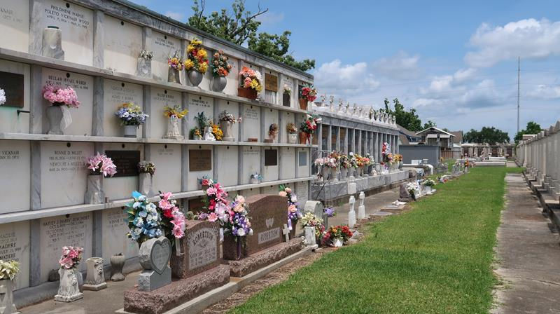

Eugene "Gene" Joseph Keller, Sr. passed away peacefully at his residence surrounded by family on Tuesday, July 1, 2025 at the age of 90. He was a native and lifelong resident of Reserve, LA. Gene was a graduate of Leon Godchaux High School and proudly served his Country in the U. S. Army. Gene retired in 1990 from Marathon Petroleum. He co-founded the St. John ARC and helped to integrate handicapped children into the school system. Gene was a member of the American Legion and VFW Posts in Reserve, and the St. Peter's Knights of Columbus.
Loving father of Debra Lynn Keller and the late Eugene J. Keller, Jr. (Lisa) and Karen Rachel Keller (Earl). Grandfather of Heather Keller (Jacob), Shelby Marino Dennis (Richie), Ashleigh Keller Jackson (David), Hailey Marino (Colton), Dakota Poche (Courtney), Eugene "Trey" J. Keller, III (Jordan), Nicholas Keller and the late Amber Keller. Great-grandfather of 17 great-grandchildren. Son of the late Sidney J. Keller, Sr. and Odette Gueret Keller. Brother of Gerald Keller (Cheryl) and the late Gloria Mae Keller, Sidney Joseph Keller, Jr., Delores Keller, Morgan Keller and Marie Therese Vicknair (Leslie "Bud"). Also survived by many nieces and nephews; his sisters-in-law, Dorothy Shipley Grubbs and Linda Shipley Fryoux; and preceded in death by his former wife and friend, Florence "Bea" Shipley Keller.
Relatives and friends are invited to attend the Funeral Service on Saturday, July 5, 2025 at St. Hubert Catholic Church, 176 Anthony F. Monica St., Garyville. Visitation will be held from 10:00 a.m. to 12:00 p.m. with the Funeral Mass to immediately follow at 12:00 p.m. Interment in St. Peter Cemetery.

Millet-Guidry Funeral Home, LaPlace, Louisiana
July 2, 2025

