Joliette (Jacob) Keller
May 16, 1890 – March 13, 1972

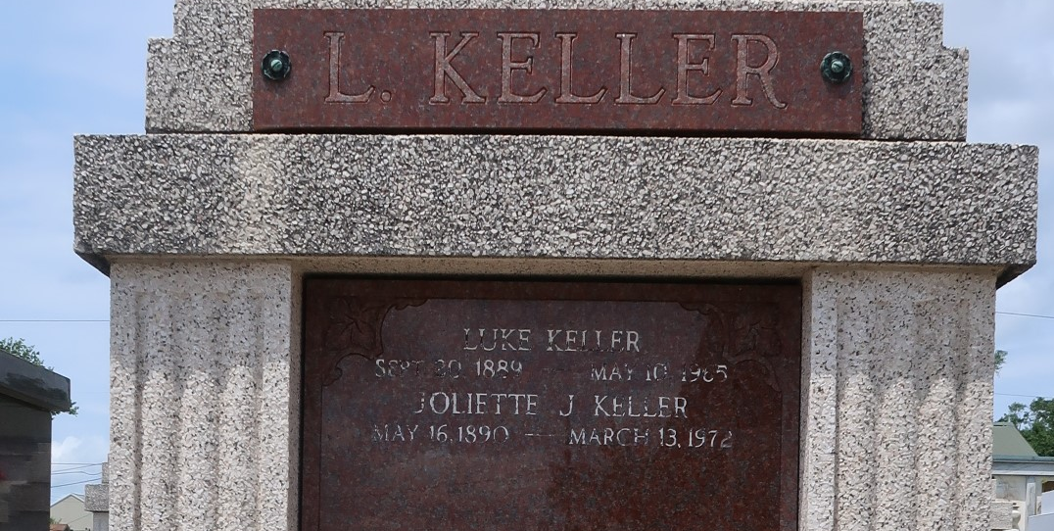

Juliette Jacob Keller died on Monday 13 Mar 1972 at 9:30 o'clock a.m. at age 81 years. She was the wife of the late Luke Keller and mother of John J Keller of Destrehan, Louisiana, Mrs. E P (Lucille) Millet, Mrs. Louis C (Anna Mae) Tanguis Jr and Mrs. Anthony (Lucres) Milioto, all of Laplace, Louisiana, Mrs. Robert (Helen) Roussell of Norco, Louisiana, and Mrs. Allen (Gloria) Scallon of Reserve, Louisiana. Also survived by 21 grandchildren and 4 great grandchildren. She was a native of Reserve and a resident of Laplace for the past 10 years.

Funeral services from Millet Funeral Home, Laplace, on Wednesday 15 Mar 1972 followed by religious services at St Joan of Arc Church, Laplace. Interment in St Peter Cemetery, Reserve.
The Times-Picayune, New Orleans, Louisiana
14 Mar 1972, p 10

