Joseph Roy Keller
June 6, 1920 – January 25, 2015

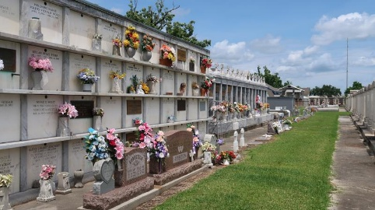

Joseph Roy Keller, age 94, entered into eternal life on Sunday, January 25, 2015. He was the son of the late Anatole and Leona Parquet Keller, and the devoted husband of the late Olivia Songy Keller for 63 years. He was a native and resident of Reserve, LA. He served proudly in the US Army during WW II and was honored with seven commendations. He retired from Godchaux Henderson Sugar Refinery in Reserve, LA after 44 years of service.
Mr. Keller leaves to cherish his memories his loving children Myrtis K. (Roy) Murphy, Mercedes K. (Alexander) Henderson, Elaine K. (Meredith) Johnson, Bernette Denise(Stanley) Reed, Malcolm (Johnnie Mae) Keller, Rev. Eric (Lennelle) Keller, Keith (Valerie) Keller, and Jason (Lisa) Keller; three generations of grandchildren; two brothers Robert (Althea) Keller and Ronnie (Lorenza Roberts) Keller; and three brothers-in-law Detroit Pidgeon Sr., Oliver (Sedonia) Songy, Jr., and Malcolm (Angela) Songy Sr., godchildren Joseph (Freddie) Valentine, Wilson Mitchell, Jr., Alicia Mitchell, Elizabeth Perrilloux, David Cook, Jules Duhe, Durell Cook, Bridgette Gibson Kitchen, Freddie Tassin and a host of nieces, nephews, cousins, other relatives and friends.
He was preceded in death by his wife, parents, one granddaughter Darlene Howard, two grandsons Darryl Howard and Russell A. Obee, Jr., one great-grandson Jeremy L. Watkins; siblings Mary Dorothy Keller, Myrtle K. Valentine, Edith K. Pidgeon, Mildred K. Taylor, Raymond, Willeana, Oleana, Cleveland and Lucien Keller; father/mother-in-law Oliver Songy, Sr. and Theresa Barre Songy; brothers/sisters-in-law Loretta S. (Walter) Stewart, Eva (Edmond Sr.) Duhe, Donald Songy, Ernest Taylor, Jr., Joseph Ferdinand Valentine and Evola W. Keller; one niece Gloria P. Deselle, three nephews Michael Pidgeon, Donald Pidgeon and Edmond Duhe, Jr.; grandparents Evariste and Harriet Louis Keller and Eusebe and Hortense Triche Parquet; godparents Henry Keller and Lydia Keller and a godson Wallace Frank III.
A Mass of Christian Burial for Mr. Keller will be held on Saturday, January 31, 2015 at Our Lady of Grace Catholic Church in Reserve, LA at 10:00 AM; Rev. Christopher C. Amadi, S.S.J. Celebrant. The rosary will be said at 9:00 AM. Visitation will be from 7:30 AM until 10:00 AM. Interment: St. Peter Cemetery, Reserve, LA. Arrangements by Rhodes Funeral Home.

The Times-Picayune, New Orleans, Louisiana
Jan. 27 to Jan. 30, 2015

