Josephine (Vicknair) Keller
July 2, 1862 – October 29, 1956

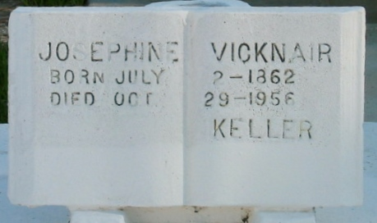
Photo by Bobby

Josphine Vicknair, age 94 years, died at her residence in Montz, Louisiana, on Monday, 29 Oct 1956. She was a native of Reserve, Louisiana, and a resident of Montz for the past 64 years. She was the wife of the late Jules Keller and the mother of Mrs. Dora Jacob, Luke, Jules, William, Noe, Guy, Leontine and Amelia Keller. She was the sister of Mrs. Aline Vicknair.

Services were Wednesday, 31 Oct 1956, at St Joan of Arc Church in Laplace, Louisiana, with interment in St Peter Cemetery, Reserve.

Unknown source

