Leatrice Theresa (Cassagne) Keller
April 19, 1929 – April 30, 2016

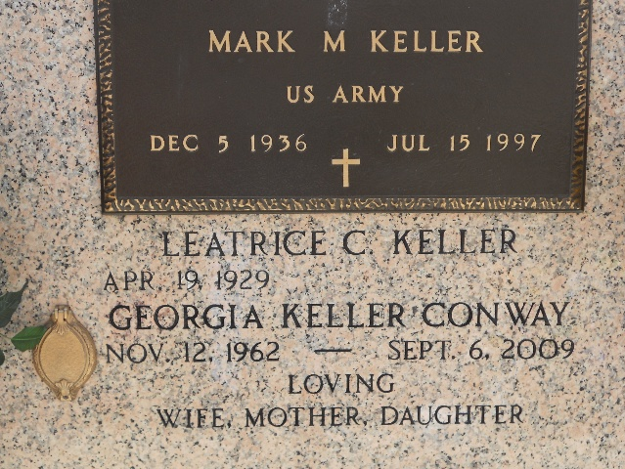
Photo by Team T-Lo

Leatrice “Cheesie” Keller, age 87, went to Heaven and joined her husband and beloved daughter on Saturday, April 30, 2016 at North Oaks Medical Center surrounded by her devoted granddaughter, family and friends. She was a lifelong resident of Reserve, LA and enjoyed cooking wonderful meals for her family and friends, as well as making crafts and building puzzles. Cheesie was a proud member of St. Peter Catholic community in Reserve, LA and she was a secretary at St. Peter Catholic School for 26 years. Cheesie was a kind, generous, loving, and beautiful woman who will be greatly missed by all.
Cheesie leaves behind her loving granddaughter, Lacey Burns; sister, Mitsy Madere; and numerous nieces and nephews, as well as many cousins.
Preceding Leatrice in death were her parents, Leelen and Effie Cassagne; husband, Mark M. Keller; and loving daughter, Georgia Keller Conway.
Relatives and friends are invited to attend the Visitation at Millet-Guidry Funeral Home, 2806 W. Airline Hwy., LaPlace on Wednesday, May 4, 2016 from 5:00 p.m. until 8:00 p.m. Visiting hours will resume on Thursday, May 5, 2016 at St. Peter Catholic Church, 1550 Hwy 44, Reserve from 9:00 a.m. until the Funeral Mass at 11:00 a.m. Interment will follow in St. Peter Cemetery in Reserve.

Millet-Guidry Funeral Home, LaPlace Louisiana

