Lena (Cambre) Keller
January 9, 1892 – August 7, 1983

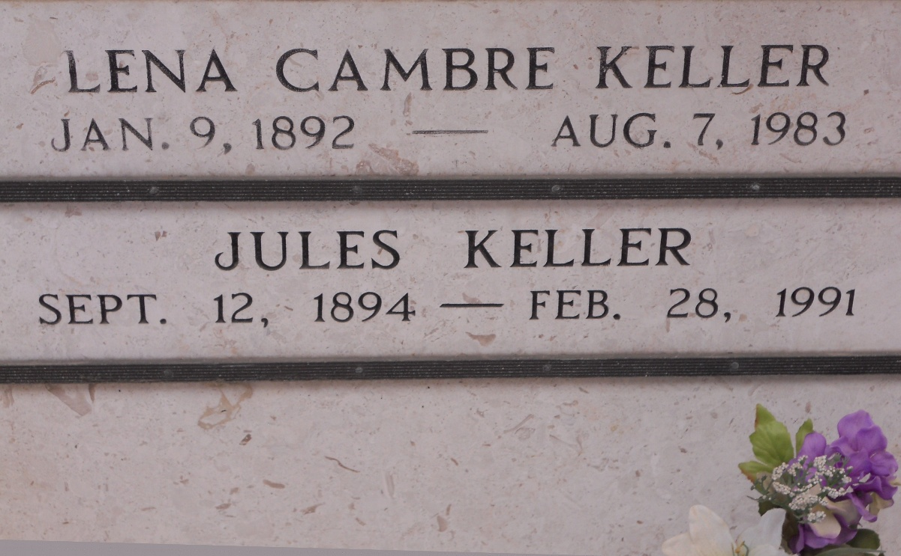
Photo by Team T-Lo

Lena Cambre Keller died Sunday 7 Aug 1983 at 6:27 am at age 90 years.

She was a native of Laplace, Louisiana, and a resident of Norco, Louisiana, for 25 years.

Wife of Jules Keller and mother of Buddy Keller. She was the sister of the late Esther Weber, Noema Brady and Edwin Cambre.

Services were Tuesday 9 Aug 1983 at Sacred Heart Catholic Church, Norco, with interment in St Peter Cemetery, Reserve, Louisiana.
The Times-Picayune, New Orleans, Louisiana
8 Aug 1983

