Leontine Keller
April 19, 1899 – June 7, 1987

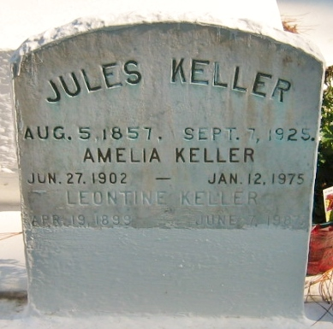
Photo by Bobby

Leontine Keller died on Sunday 7 Jun 1987 at 8:25 p.m. at age 88 years.
She was the daughter of the late Jules Keller Sr and Josephine Vicknair Keller and the sister of Jules Jr and Noe Keller of Norco, Louisiana, and Guy Keller of Winnie, Texas, and the late Dora Jacob, Luke, William and Amelia Keller. Also survived by 18 nieces and nephews. She was a native of Montz, Louisiana, and a resident of Laplace, Louisiana, for the past 22 years.
Funeral services were from Millet Funeral Home, 605 Main Street, Laplace, with a Mass of Christian Burial at St Joan of Arc Catholic Church, Laplace, on Tuesday 9 Jun 1987. Interment in St Peter Cemetery, Reserve, Louisiana.
The Times-Picayune, New Orleans, Louisiana
June I, 1987

