Luke Keller
September 20, 1889 – May 10, 1965

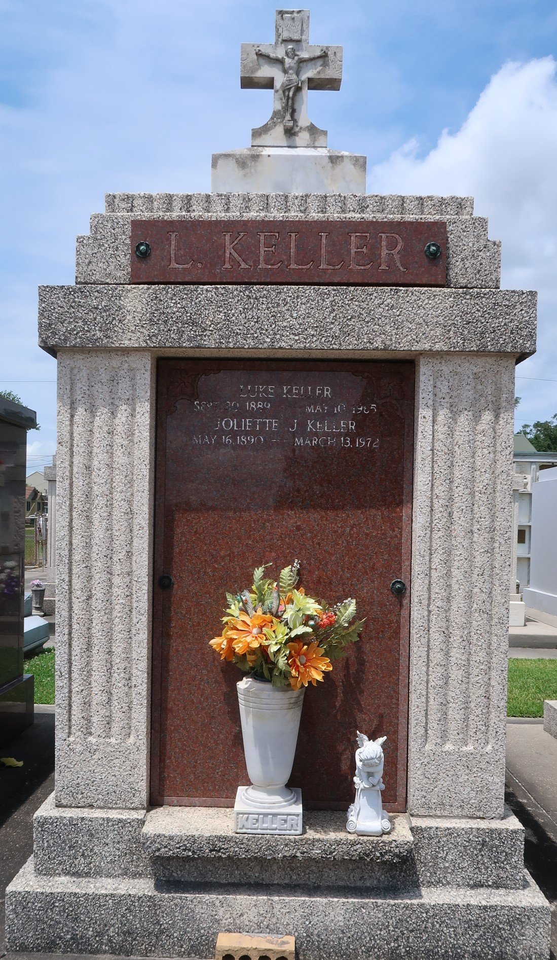

Luke Keller died on Monday 10 May 1965 at 11:45 p.m. at age 75 years. He was the husband of Juliette Jacob and the father of John Keller of Destrehan, Louisiana, Mrs. E P Millet Sr, Mrs. Anthony Milioto, Mrs. Jessie Tanguis, all of Laplace, Louisiana, and Mrs. Allen Scallan of Reserve, Louisiana, and Mrs. Robert J Roussell of Norco, Louisiana. He was the brother of Noe Keller, Jules Keller Jr and William Keller, all of Norco, Guy Keller of Houston, Texas, Mrs. Maxie Jacob, Misses Leontine and Amelia Keller of Montz, Louisiana, and the late Emma Keller. Also survived by 21 grandchildren.
He was the son of the late Josephine Vicknair and Jules Keller Sr, a native of Reserve, a former resident of Montz and now of Laplace for the past six years.
Funeral services from Millet Funeral Home, Laplace, with religious services at St Joan of Arc Church, Laplace, on Wednesday 12 May 1965. Interment in St Peter Cemetery, Reserve.
The Times-Picayune, New Orleans, Louisiana
May 12, 1965, p. 2

