M. Delores Keller
June 28, 1932 – December 28, 2008

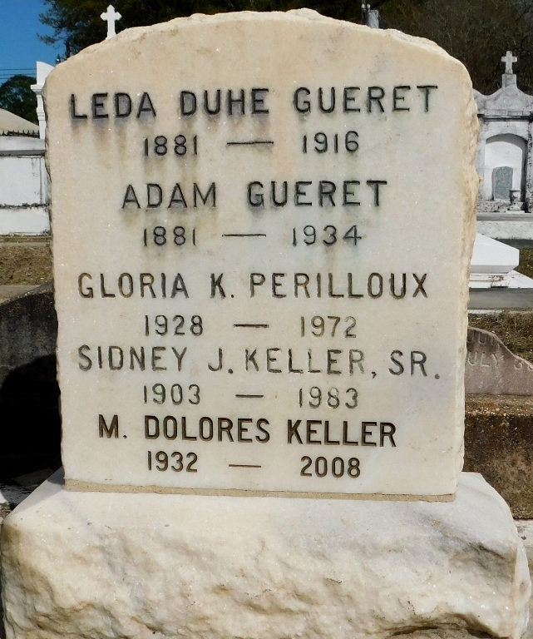
Photo by Mary Agnes Hammett

Mary Dolores Keller on Sunday, December 28, 2008 at 2:20am. Beloved mother of Barbara Ann Keller. Daughter of the late Sidney J. and Odette Gueret Keller, Sr. Sister of Eugene and Gerald Keller and the late Sidney Jr. and Morgan Keller, Theresa K. Vicknair and Gloria K. Perilloux. Age 76 years. A native and resident of Reserve, La. Relatives and friends are invited to attend services.
Visitation at Millet-Guidry Funeral Home, 2806 W. Airline Hwy, LaPlace, La., on Wednesday, December 31, 2008 from 8:30am to 9:45am. Followed by Religious Services at St. Peter Catholic Church, Reserve at 10:00am. Burial in St. Peter Cemetery Reserve, La.

The Times-Picayune, New Orleans, Louisiana
December 30, 2008

