Mae (Montz) Keller
May 25, 1908 – November 21, 2003

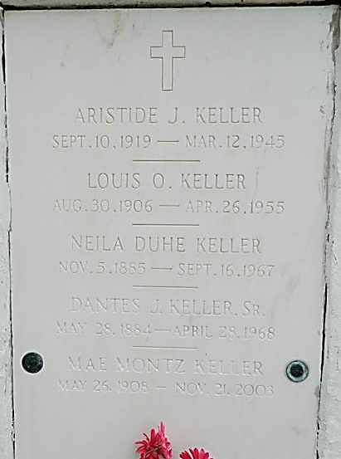

Mae Montz Keller, on Friday, November 21, 2003 at 6 A.M.

Beloved wife of the late Louis Keller. Mother of Harold Keller, Judith Duhon and the late Mark Keller and Lillie Mae Reno. Sister of Carl Montz. Also survived by 14 grandchildren and 31 great-grandchildren.

Age 95. A native and resident of Reserve.

Private services were held on Saturday, November 22, 2003. Arrangements by Millet Guidry Funeral Home, Laplace.
The Times-Picayune, New Orleans, Louisiana
November 23, 2003

