Mary Catherine (Jacob) Keller
September 12, 1936 - October 22, 2020

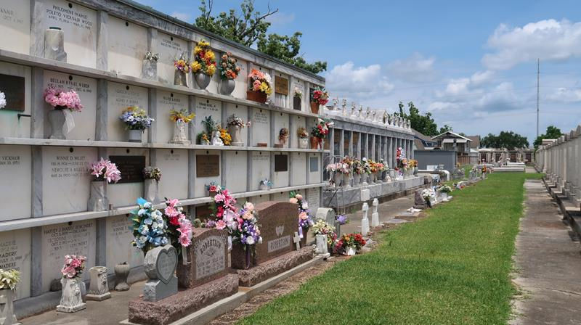

Mary Catherine “Cat” Keller, a resident of Reserve, passed away on Thursday, October 22, 2020 at the age of 84. She retired after 47 years of service with the Archdiocese of New Orleans. A lifelong member of the St. Peter Catholic Community. She truly loved her work and was devoted to St. Peter School. In February of 2006, she received the St. Peter Catholic School Distinguished Graduate Award. Cat enjoyed spending time outdoors as an avid gardener and nature lover. She loved spending time with her family – especially her grandchildren. She will be greatly missed by all who knew her.
She is survived by her children, Celeste Deslatte (Rickey), Julian Keller (Donna), Myra Catoir and Noemie Maurice (Steve); grandchildren, Candace Schiro (Joey), Dustin Deslatte (Kallie), Amber Caronna (Vic), Mary Maurice, Scott Keller, Lindsey Louque (Brison), Allen Keller, Roger Catoir, Ashley Kliebert (Phillip) and Missy Catoir; great-grandchildren, Jayce Catoir, Kase Hession, Jaxon Anderson, Arianna Silva, Gage Kliebert, Kallie Deslatte, Brantley Schiro, Adalida Deslatte and Victoria Rapp; brother, Lawrence Jacob; and sisters, Shirley Duhe and Norma Woodard.
She is preceded in death by her husband, Carol L. Keller; parents, Angelo and Celeste Jacob; brothers, Andrea Jacob, Herman Jacob, Jessie Jacob and Kenneth Jacob; and sisters, Ethel Duhe and Marion Landry.
A visitation will be held on Tuesday, October 27, 2020 at St. Peter Catholic Church in Reserve from 9:00 AM until the Mass of Christian Burial at 11:00 AM. Interment will follow in the church cemetery.
The family would like to thank the staff of St. Catherine’s Hospice.
In lieu of flowers, please make donations to St. Peter School, 188 West 7th St., Reserve, LA 70084.

Rose Lynn Funeral Home, Lutcher, Louisiana

