Mildred (Gendron) Keller
December 13, 1921 – July 17, 2008

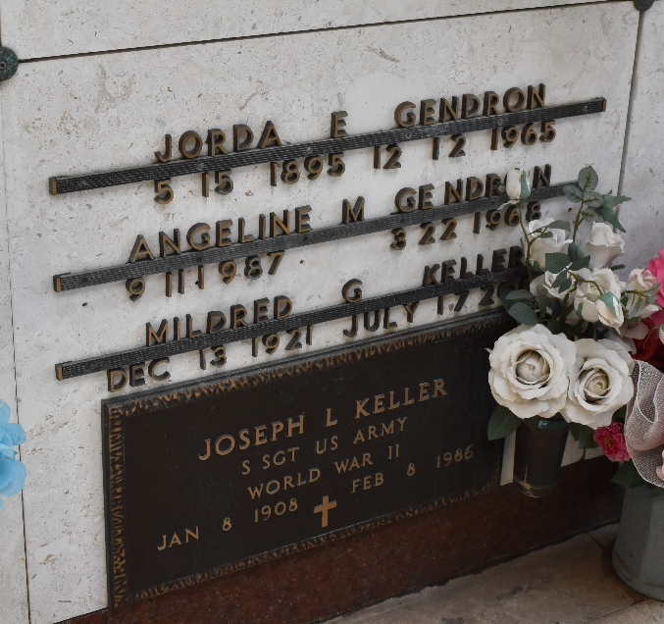

Mildred Gendron Keller on Thursday, July 17, 2008 at 2 AM. Beloved wife of the late Joseph (Joe) Keller. Mother of Joseph (Jay) Keller, Jr. Daughter of the late Jorda and Angeline Gendron. Sister of Dowie Gendron and Earline Duhe.
She was a retired teacher and librarian at Leon Godchaux High School, East St. John High School and St. John Public Library after 44 years.
Thanks to the Staff and CNA's at Twin Oaks Nursing Home and Dr.'s Bailey, Tegala, St. Martin and St. Germain.
Age 86 years. A native of LaPlace and a resident of Reserve.
Relatives and friends, also St. Peter Ladies Altar Society are invited to attend services. Visitation at St. Peter Catholic Church, Reserve, La. on Tuesday, July 22, 2008 from 9 AM to 10 AM. Followed by Religious Services at St. Peter Catholic Church, Reserve at 10 AM. Burial in St. Peter Cemetery, Reserve, La.
In lieu of flowers, donations preferred to St. Peter Catholic School. Arrangements by Millet-Guidry Funeral Home.

The Times-Picayune, New Orleans, Louisiana
July 18, 2008

