Neila (Duhe) Keller
November 5, 1885 – September 16, 1967

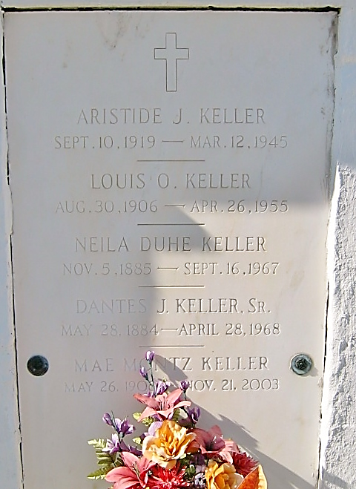

KELLER - At Hotel Dieu, New Orleans, Louisiana, on Saturday, September 16, 1967, at 8:40 o'clock a.m., NELIA DUHE KELLER, beloved wife of Dantes J Keller Sr, mother of Joseph, Percy and Carol Keller and Mrs. Alvin V Zewe?, all of Reserve, Louisiana, Nolan Keller, Mrs. Roy Schexnayder and Dantes J Keller Jr, all of Baton Rouge, Louisiana, and the late Louis and Aristide Keller; also survived by 30 grandchildren and 7 great grandchildren, age 81 years and 10 months, a native and a resident of Reserve, Louisiana.
Relatives and friends of the family are invited to attend the funeral. Services from Millet Funeral Home, Reserve, Louisiana, on Monday, September 18, 1967 at 10 o'clock a.m., religious services at St Peter Church, Reserve, Louisiana. Interment in Church Cemetery.
The Times-Picayune, New Orleans, Louisiana
17 Sep 1967, p. 4

