Norman J. Keller
March 26, 1916 – August 5, 2003

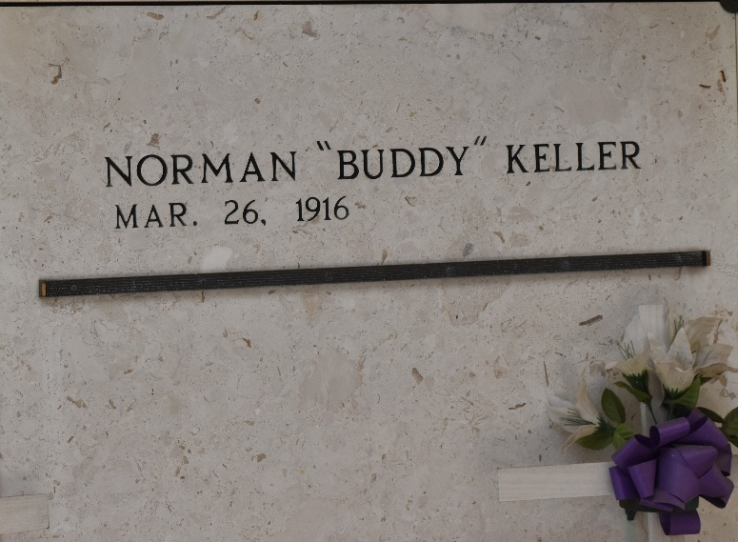

Norman J. 'Buddy' Keller On Tuesday, August 5, 2003 At 6:35 Pm In Laplace, La. Age 87 Years. A Native Of Montz, La And A Resident Of Destrehan, La For The Past 4 1/2 Years, Formerly A Resident Of Norco, La Until 1999.

Son Of The Late Jules Jr. And Lena Cambre Keller. He Was A World War II Veteran And A Retired Employee Of Shell Oil Refinery. Also Survived By A Number Of Cousins And Friends.

Mass Of Christian Burial At 11:00 Am On Friday, August 8, 2003 At St. Charles Borromeo In Destrehan, La. Interment In St. Peter Mausoleum In Reserve, La. Visitation At St. Charles Borromeo In Destrehan From 10 To 11 Am On Friday Morning. H.C. Alexander Funeral Home Of Norco In Charge
The Times-Picayune, New Orleans, Louisiana
August 7, 2003

