Rodney Martin Keller
January 11, 1959 – May 28, 2008

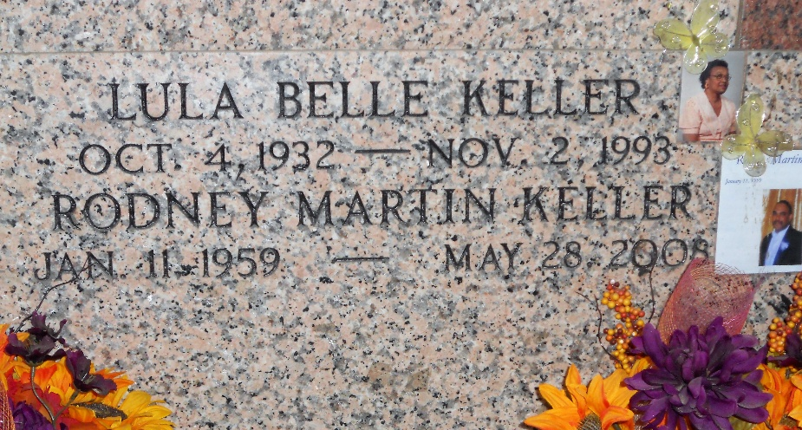
Photo by Team T-Lo

Rodney Martin Keller on Wednesday, May 28, 2008. Son of Calvin Keller and the late Lulabelle B. Keller. Wife of Shirley Martin Keller. Father of Kinley Keller, Danielle and Katherine Keller. Brother of Roxanne Keller Lumar. Brother in law of Jerry Lumar. Also survived by 2 granddaughters, 2 nephews, other relatives and friends. Age 49 years. A native of Reserve, LA and a resident of LaPlace, LA.
Relatives and friends of the family, also priest and parishioners of Ascension of Our Lord and Our Lady of Grace Catholic Churches and all neighboring churches, and employees of Marathon Oil and St John the Baptist Parish School System are invited to attend the Mass of Christian
Burial at Ascension of Our Lord Catholic Church, 1809 Greenwood Drive, LaPlace, LA, on Friday, June 6, 2008 at 11:00 AM. Father Walter Austin, Pastor of Ascension of Our Lord Catholic Church, Father Joseph Rodney, Celebrant, Pastor of Our Lady of Grace Catholic Church. Interment St Peter Cemetery, Reserve, LA. Visitation at the above-named church from 9:30 AM until Mass time. SERVICED BY ROBOTTOM
The Times-Picayune, New Orleans, Louisiana
June 5, 2008

