Wilbert Felix Keller
December 31, 1930 – April 25, 2009

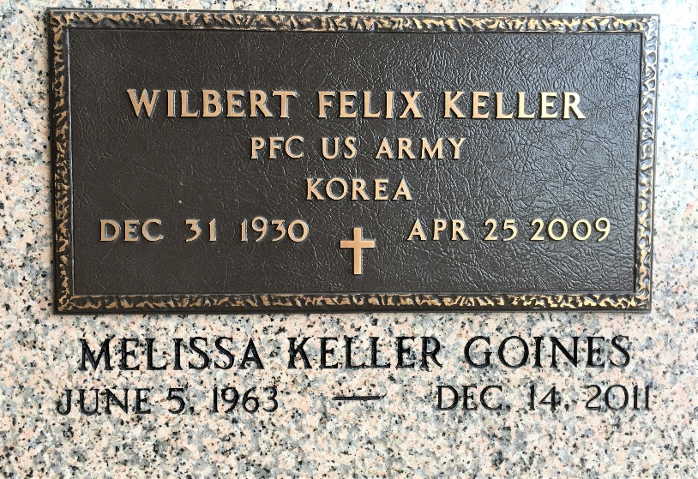
Photo by Team T-Lo

Wilbert Felix Keller On Saturday, April 25, 2009 At River Parishes Hospital, Laplace, LA.

Son Of The Late Walter And Nellie Gauff Keller. Husband Of Josephine 'Josie' Mitchell Keller. Father Of Melissa Keller Goines 'Ivy', Wilbert Jude Keller 'Devita', Wayne Keller 'Kelly', And Lori Keller. Brother Of Walter Keller, Jr. 'Isabella', Alma Keller Adams, The Late Nellie Keller Joseph And Leroy 'Kute' Keller. Brother-In-Law Of Juanita And Warren White And Jerry Mitchell. Also Survived By 8 Grandchildren.
Age 78 Years. A Native And Lifelong Resident Of Reserve, La.
The Times-Picayune, New Orleans, Louisiana
April 29, 2009

