Cecile (Triche) Kilchrist
June 19, 1878 – March 2, 1927

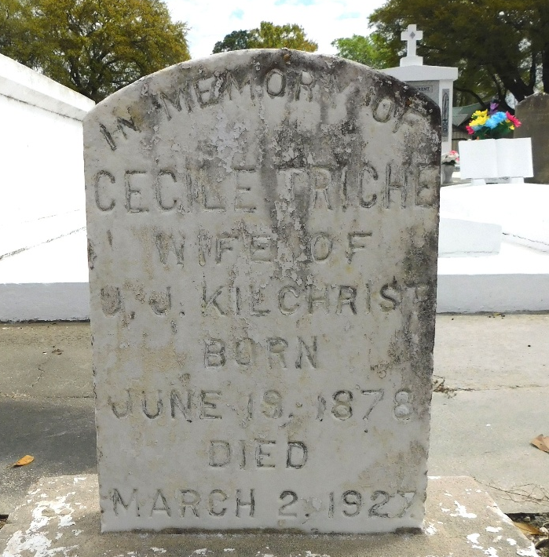
Photo by Mary Agnes Hammett

Cecile Triche, a native of Reserve, Louisiana, and a resident of Port Neches, Texas for the past 10 years, died Wednesday 2 Mar 1927 at 12:40 p.m. at age 48 years.

She was the wife of Ulysse Kilchrist, and the daughter of the late Isidore Triche and Rosa Lasseigne.

Services were Thursday 3 Mar 1927 with interment in St Peter Cemetery, Reserve.
The Times-Picayune, New Orleans, Louisiana
March 3, 1927

