Ann Elise (Smith) Kimball
April 17, 1932 – October 23, 2024

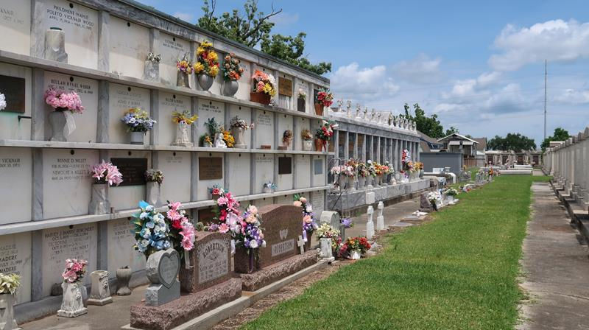

Mrs. Ann Elise Kimball, 92, passed away Wednesday, October 23, 2024, at her home in Oxford, Mississippi. A memorial service will be held on Saturday, November 16, 2024 at St Peter's Catholic Church, 1550 Highway 44, Reserve, LA. Visitation at 10AM with Mass at 11AM. Interment to follow at St Peter's Cemetery. Father Ray Hymel will be officiating. Coleman Funeral Home of Oxford is in charge of local arrangements.
Ann was born on April 17, 1932, in New Orleans, Louisiana, and was raised, along with her sisters and brother, by loving parents in Reserve, Louisiana. Her drive and determination led her to graduate with a Business degree from Spencer Business College in New Orleans. Ann continued to excel in her working years, climbing her way up to an executive secretary position for an oil and gas producer, where she ultimately retired. Throughout her working years, she was also a proud member of the Desk and Derrick Club of New Orleans, which is an organization for workers in the oil and gas industry.
Ann was known to have an outgoing personality and was such a free spirit. She had a way of making other people feel so comfortable around her and these traits seemed to draw people to her wherever she went. She had a very special place in her heart for children, and was always delighted when surrounded by her grandchildren and great-grandchildren. Ann also enjoyed dancing, singing and performing, especially when she was a member of the Sweet Adelines Club in Lafayette, Louisiana. She was also known to be extremely creative, often making all sorts of arts and crafts. Although she loved to travel, she always said her happiest place was fishing and relaxing with her late husband, George at their camp on False River in Ventress, Louisiana. Ann truly lived a long and happy life, and she will be dearly missed by all who knew her.
Ann is survived by her two daughters, Ann (Cliff) Richardson of Oxford, and Karen (Charles) Fleischer of Stillwater, Oklahoma; four grandchildren, Jennifer (Sonny) Mounicou of Olive Branch, Mississippi, Tiffany (Peter) Stein of Cabot, Arkansas, Terrick (Alyssa) Turner of Stillwater, Oklahoma, and Logan Fleischer of Stillwater, Oklahoma; seven great-grandchildren, Alexander Mounicou, Michael Mounicou, Maren Stein, Dylen Stein, Hayden Stein, Charlie Turner, and Scout Turner; two sisters, Joycelyn Smith Monica of Garyville, Louisiana, and Phyllis Smith Martin of LaPlace, Louisiana; and a host of nieces, nephews, and extended family members.
Ann was preceded in death by her husband George W. Kimball; her parents, Allen F. Smith, Sr. and Solange Jaubert Smith; and her brother, Allen F. Smith, Jr.
Donations and memorials in honor of Mrs. Ann Kimball may be made to St. Jude Children's Research Hospital.

The Advocate, Baton Rouge, Louisiana
November 10, 2024

