Eugenie (Catoire) Klibert
July 26, 1904 – June 27, 2001

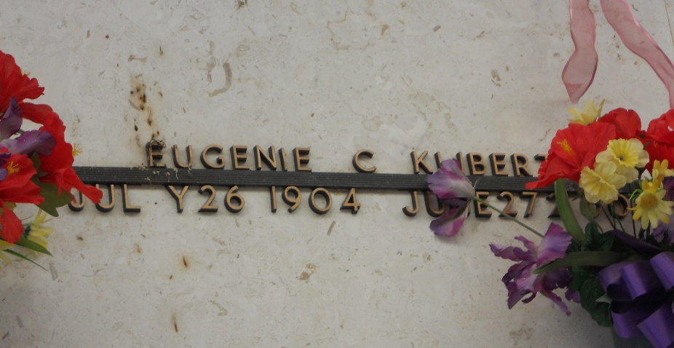
Photo by Team T-Lo

LAPLACE – Eugenie Catoire Klibert, 96, a native of Reserve and resident of LaPlace for 21 years, died June 27.
She was the wife of the late Elmore Klibert and mother of Mary Singler, Gilda Lasseigne, Patty Clement and Judith Cancienne. She is also survived by 19 grandchildren, 29 great-grandchildren and seven great-great-grand-children.
Services are today at noon in the chapel of Millet-Guidry Funeral Home, LaPlace, with interment at St. Peter Cemetery, Reserve. Visitation starts at 10 a.m.
L'Observateur, LaPlace, Louisiana
Saturday, June 30, 2001

