George J. Klibert
December 5, 1953 – April 18, 2014

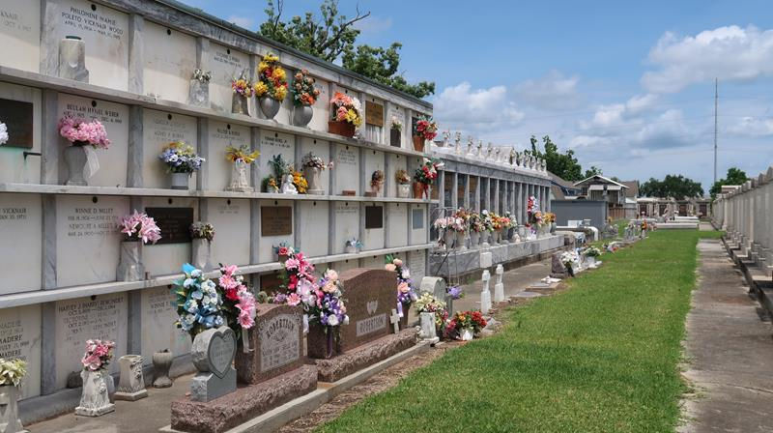

George "Lightning" Klibert, age 60, was born on December 5, 1953 and passed away on April 18, 2014. He was a native of New Orleans and a resident of Reserve.
He is survived by his wife, Kelly Thomas Klibert; his Mother, Marian Petit Klibert; stepson, Dylan Guidry; brother, Chris Klibert (Kelly); 2 sisters: Cynthia Klibert Crawford, and Janine Klibert Mohon (Stephen) as well as his Godson, Jeremy Crawford and brothers-in-law: Daniel Millet, Jr. (Amber), Adam Millet (Beth), Jules "Peter" Millet, III, and Father in- law and Mother in- law, Danny and Henrietta Millet.
He was preceded in death by his Father, Curtis Klibert, grandparents: Roger and Leonie Petit, and Theophile and Palmire Klibert. He retired from Shell Norco after 28 years of service. He was a member of the Labranche Duck Club.
Visitation will be on Friday, April 25, 2014 from 9:00 a.m. until 10:45 a.m. at St. Peter Catholic Church in Reserve followed by a Mass of Christian Burial at 11:00 a.m. Burial will follow in the Church cemetery. ROSE LYNN FUNERAL SERVICES is in charge of the arrangements.

The Advocate, Baton Rouge, Louisiana
Apr. 23 to Apr. 24, 2014

