Helen (Waguespack) Klibert
Mar 22, 1928 - Jan 08, 2024

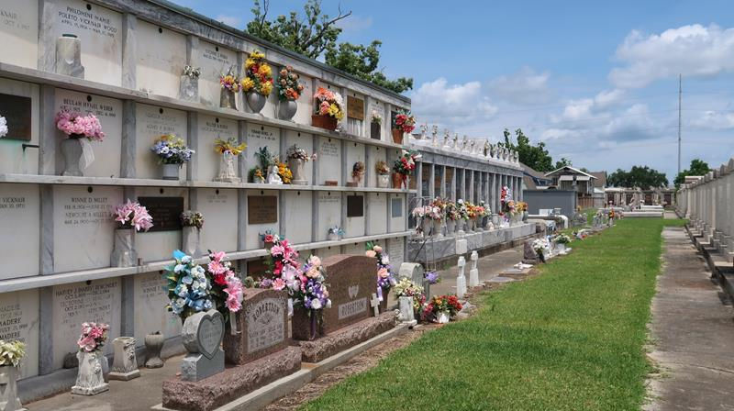

Helen Waguespack Klibert passed away on Monday, January 8, 2024 at the age of 95. She was a lifelong resident of Reserve, LA.
Beloved wife of the late Adrian Klibert. Loving mother of Diane Pecoul (the late John), Joanne Falterman (Philip), Linda Nowell (Tootie), and the late Kitty Falgoust (Ronnie), Marilyn Hidalgo (the late Bobby). Grandmother of 8 and one deceased. Great grandmother of 12. Great-great grandmother of 1. Daughter of the late Winton Waguespack and Lolita Perrett Wagues-pack. Sister of the late Lolita Martinez, Alva Beadle, Winton Waguespack, Jr. Also survived by numerous nieces, nephews, and cousins.
Relatives and friends are invited to attend the Visitation and Funeral Mass at St. Peter Catholic Church, 1550 Hwy 44, Reserve on Friday, January 12, 2024. Visitation will be held at the church from 9:00 a.m. to 11:00 a.m. followed by a Funeral Mass at 11:00 a.m. Interment in St. Peter Cemetery, Reserve, LA.
Rose Lynn Funeral Home, Lutcher, Louisiana
January 10, 2024

