Jeffery Bodean Klibert
November 10, 1954 – July 31, 2016

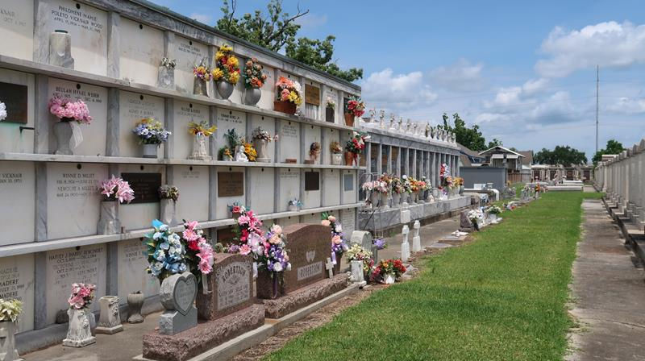

Jeffery "Bodean" Klibert passed away at his residence on Sunday, July 31, 2016 at the age of 61. He was a native of Reserve and a resident of Garyville. He was employed as a dispatcher for Holcim, formerly Lafarge, for many years.
Beloved husband of Carolyn Fuselier Klibert. Loving father of Jeremy Klibert (Liz), Jenny K. March (Justin) and Shawn Klibert (Natalie). Grandfather of Logan, Ava and Jackson Klibert and Teegan March. Son of the late Eldridge and Marion Klibert. Brother of Paula K. Stromeyer (Elroy), Amy K. Lambert (Donnie), Sue Klibert and Henry Klibert (Lynn). Son-in-law of Rose Fuselier and the late Gene Fuselier. Brother-in-law of Sandra Miller. Also survived by nieces and nephews.
Relatives and friends are invited to attend the Funeral Mass on Thursday, August 4, 2016 at 12:00 p.m. at St. Peter Catholic Church, 1550 Hwy 44, Reserve. Visitation will begin in church at 10:00 a.m. Interment in St. Peter Cemetery. Arrangements by Millet-Guidry Funeral Home.

The New Orleans Advocate, Louisiana
Aug. 1 to Aug. 8, 2016

