Joseph W. Klibert
November 29, 1927 – June 23, 2018

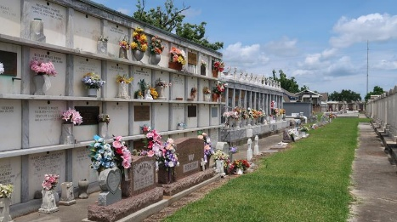

Joseph “Willie” Klibert was born on November 29, 1927 and entered eternal peace and rest on June 23, 2018 in the Southeast Louisiana War Veterans Home, Reserve, LA. He was 90 years old. He was a lifetime resident of Reserve, LA. He was preceded in death by his wife of 59 years, Marie Louise Roussel Klibert; his parents, Henry and Stephanie “Fallie” Scioneaux Klibert; his only brother, Eldridge Klibert; and son-in-law, Brian Melancon. Father and father-in-law of Sheila K. Melancon; Donna K. and Chester “Chuck” Lemoine; Kevin “Booga” and Melissa “Malou” Vicknair Klibert; and Ronnie and Cindy Brignac Klibert. Grandfather of Darby, Dustin, Darcie, Drake, Brandi, Brooke, Joshua, Dylan, Nicole, Kaila and Brandon. Great grandfather of Ridge, Talan, Brianna, Briar, Kennedie, Alexus, Drake Jr., Blair, Brysen, Kole, Briggs, Knox, Kelin and Scarlett.
Willie served his country in the U.S. Air Force and was stationed in Japan. He received the WWII Victory Medal and the Army Occupation Medal for Japan. He was a member of the Reserve Volunteer Fire Department and a member and former commander of V.F.W. Post 5004.
Willie loved people and he loved to dance. He liked to piddle in carpentry and his favorite pastime was repairing bicycles and lawn mowers. He worked as a pole lineman for South Central Bell, a courier for the Bank of St. John, an employee at Godchaux-Henderson Sugar Refinery as a quality control personnel, a custodian at the Leon Godchaux High School, staff personnel for Millet’s Funeral Home and sold American Hemlock Insurance. He enjoyed camping and attending Friday night high school football games. He also enjoyed watching L.S.U. and the Saints games on television.
The family would like to extend their sincere gratitude, appreciation and thanks for the care provided to their Dad by the entire staff at the Southeast Louisiana War Veterans Home in Reserve, LA. Also a special thanks to dear family friend, Barbara Maurin, for providing care during their Dad’s needy time and to St. Joseph Hospice as Willie came to the close of his Earthly journey.
Relatives and friends are invited to attend the Funeral Mass at St. Peter Catholic Church, 1550 Hwy 44, Reserve on Friday, June 29, 2018 at 11:00 a.m. Visitation at the church from 9:00 a.m. to 11:00 a.m. Interment in St. Peter Cemetery, Reserve.

Millet-Guidry Funeral Home, LaPlace, Louisiana
June 26, 2018

