Lloyd D. Klibert Sr.
January 1, 1930 – September 26, 2016

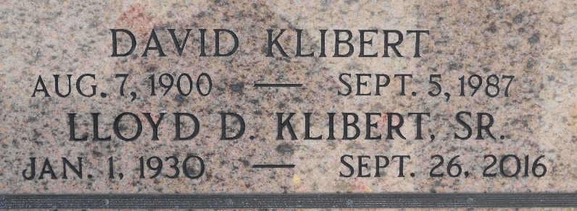
Photo by Team T-Low

Lloyd D. Klibert, Sr. went to his heavenly home on Monday, September 26, 2016 at 12:05 p.m. after a prolonged bout with Alzheimer’s disease.
He was preceded in death by his parents David and Armantine (Oubre) Klibert, two brothers, A.J. Klibert and Harold Klibert, Sr. (Thelma), and one sister Betty Naquin (John).
He will be sorely missed by his beloved wife of 34 years Elaine LaJaunie Billiot Klibert and his surviving sister Dorothy “Dot” Roussel (Garland) as well as numerous and loving nephews and nieces. He is the father from his first wife Rona Waguespack Klibert of Lloyd D. Klibert, Jr. (Beth), Brian Klibert (Paula), Jody Torres (Jose), and Linda Powers. He was “Pappy” to 13 grandchildren and 8 great grandchildren. Lloyd was “Dad” to stepsons Barry Billiot (Holly) and Garry Billiot (Cindy).
He was a parishioner of Immaculate Conception Church for 34 years and a member of the Servants of Bethany. Lloyd was a Korean veteran and member of American Legion Post 350 in Metairie. He was also an avid doubloon collector and member of the Crescent City Doubloon Traders. Lloyd also enjoyed spending time with his friends at the Marrero/Harvey Senior Center. He retired after 44 years with the Norfolk Southern Railroad.
Relatives and friends are invited to attend the Funeral Mass at L. A. Muhleisen & Son Funeral Home, 2607 Williams Blvd., Kenner on Friday, September 30, 2016 at 11:00 a.m. Visitation from 9:00 a.m. to 11:00 a.m. Interment in St. Peter Cemetery, Reserve.
L. A. Muhleisen & Son Funeral Home, Kenner, Louisiana

