Mary Ann (Triche) Klibert
August 25, 1926 – April 7, 2001

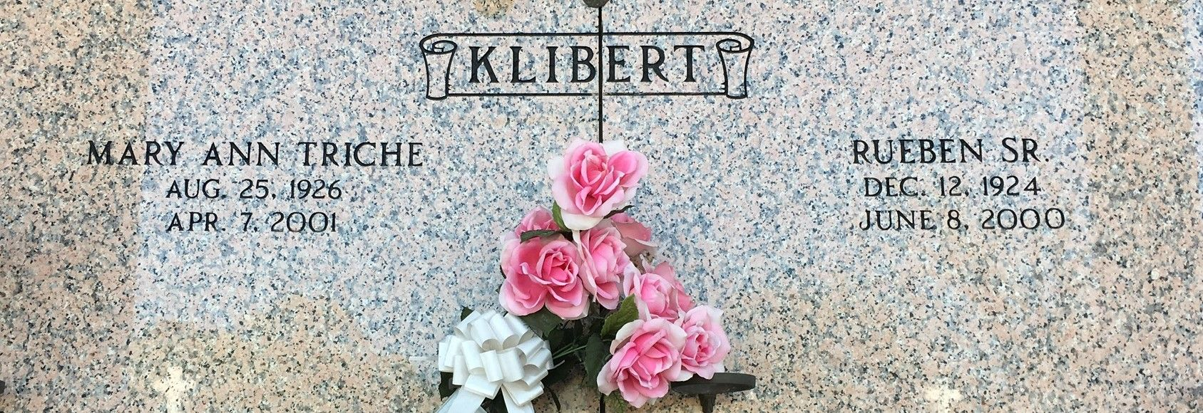
Photo by Team T-Low

RESERVE - Mary Ann Triche Klibert, 74, a native of Reserve and resident of LaPlace for 35 years, died April 7.
She was the wife of the late Rueben J. "Bonnie" Klibert and mother of Karen Hillhouse and Suzanne, Rueben Jr., Dale, Richard, Wade, Tim, Cindy, Jamie, Jeff and Ja-need Klibert. She was also the daughter of the late Morris and Marie E. Triche and sister of Rose Mae Hymel and Donald and the late Morris Jr. Triche. She is also survived by 13 grandchildren and three great-grandchildren.
Services were April 9 at St. Joan of Arc Catholic Church, LaPlace, with interment at St. Peter Cemetery, Reserve.
L'Observateur, LaPlace, Louisiana
April 11, 2001

