Reuben Joseph Jr.
August 3, 1947 – November 15, 2021

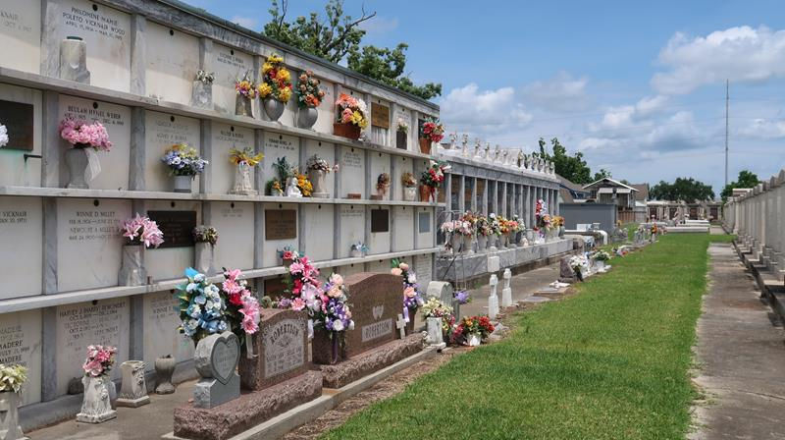

Reuben Joseph Klibert, Jr., born on August 3, 1947, a native of Reserve, LA and resident of Forney, TX, beloved husband of Pamela Kelley Klibert for 11 years passed away on November 15, 2021 at the age of 74 at his home.
Preceded in death by his parents, Rueben J. Klibert and Mary Ann Triche Klibert; brother, James Wade Klibert (Belinda Guidroz); and wife Dale Ann Mendel Klibert. Survived by stepchildren, Clint Gallo (Kim), Christopher Gallo (Paola), Daniel Gallo (Tish), Melissa Wood (Steven), and Jennifer Howe (Johnny); grandchildren, Justin Gallo (Dani), Devin Gallo, Danielle Gallo, Angelina Gallo, Chris Gallo, Rebecca Wood, Jacqueline Wood, and Addison Howe; siblings, Richard Klibert (Suzanne), Karen Klibert Curren (Nelson), Timothy Klibert (Cindi), Jamie Q. Klibert, and Jeffery Klibert (JaNeen); and many nieces and nephews.
Reuben graduated from Leon Godchaux High School in Reserve, LA, class of 65, and attended LSU. Reuben worked in the oilfield service industry for over 40 years and was a founding partner of Data Log, Inc. and Diversified Well Logging both of Reserve, LA. Reuben retired in 2012 and spent his retirement traveling and exercising his passion for LSU sports, especially baseball. Reuben was a member of the LSU baseball coaches committee. Reuben was a generous giver and helped many family, friends and strangers in difficult situations. He will be missed by his entire family.
Relatives and friends are invited to attend the Visitation and Memorial Mass at St. Peter Church, 1550 Hwy 44, Reserve, LA on Tuesday, November 30, 2021. Visitation from 9:00 a.m. to 11:00 a.m. followed by a Memorial Mass at 11:00 a.m. In lieu of flowers, please consider a donation in his memory to the American Kidney Foundation of Louisiana, 8200 Hampson St. # 425, New Orleans, LA 70118. Arrangements by Millet-Guidry Funeral Home.

The Times-Picayune, New Orleans, Louisiana
Nov. 23 to Nov. 30, 2021

