Ruth Ann (Hymel) Kliebert
December 18, 1921 – June 27, 2014

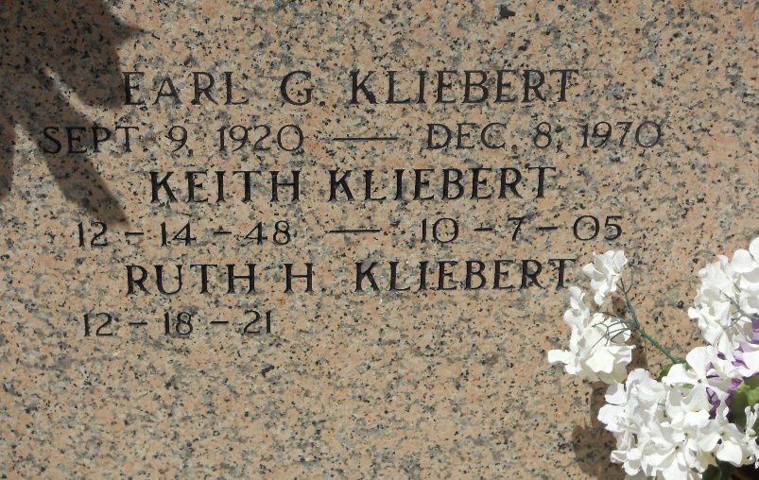
Photo by Team T-Lo

Ruth Hymel Kliebert died on Friday June 27, 2014. Beloved wife of the late Earl Kliebert. Mother of Marcia Kliebert and the late Keith Kliebert. Grandmother of Jennifer Carter, Allison Watts, Adrienne Wilkins and Catherine Landry. Great-grandmother of Nathaniel Carter, Brycen Watts, Haddie Wilkins and Taylor Grayson. Daughter of the late Numa and Louise Hymel. Sister of Sr. Mary Osanna, Ray Hymel and the late Estelle Duhe, Louise Remondet, Maizie Jacob, Shirley, Numa Jr., and Daniel Hymel. She was a member of the Ladies Altar Society. Age 92. A native of Wallace, LA and a resident of Reserve, LA.
Relatives and friends are invited to attend services. Visitation at St. Peter Catholic Church, Reserve, LA on Wednesday July 2, 2014 from 9:00am to 11:00am, followed by Mass at 11:00am. Burial in St. Peter Cemetery. Arrangements by Millet-Guidry Funeral Home, LaPlace, LA.
The New Orleans Advocate, Louisiana
June 27-July 2, 2014

